Lesson Plan Format
LESSON  PLAN COMPONENT | DAY ONE | DAY TWO | DAY THREE
Topic of Lesson and Curricular Structure (Contrastive Analysis: Read Aloud) | Beauty and brilliance of multiple languages: “My Name is Yoon” bookwalk and powerpoint about multilingualism | Codeswitching and language structures: Read aloud “Bippity Bop Barbershop” and powerpoint about language structures | Contrastive Analysis:  Poetry translation and charts
ELA Standards & Indicators Addressed (at least four) | 8.1 Explain how the author uses words and phrases to inform, explain, or describe  Standard 2: Demonstrate understanding of spoken words, syllables, and sounds.  5.1 Acknowledge and value individual and collective thinking  1.2 Participate in discussions; ask questions to acquire information concerning a topic, text, or issue.  a.1 Use text evidence to: a. describe characters’ traits, motivations, and feelings and explain how their actions contribute to the development of the plot; and b. explain the influence of cultural and historical context on characters, setting, and plot development | Standard 1: Formulate relevant, self-generated questions based on  interests and/or needs that can be investigated.  1.1 Formulate questions to focus thinking on an idea to narrow and direct  further inquiry.  8.1 Explain how the author uses words and phrases to inform, explain, or describe  a.1 Use text evidence to: a. describe characters’ traits, motivations, and feelings and explain how their actions contribute to the development of the plot; and b. explain the influence of cultural and historical context on characters, setting, and plot development  2.1 Explore topics of interest to formulate logical questions; build knowledge; generate possible explanations; consider alternative views. | 11.2 Describe the structures an author uses to support specific points.  9.2 Explain how the author’s choice of words, illustrations, and conventions combine to create mood, contribute to meaning, and emphasize aspects of a character or setting.  Standard 2: Transact with texts to formulate questions, propose explanations, and consider alternative views and multiple perspectives.  3.1 Develop a plan of action for collecting relevant information from primary and secondary sources.  3.2 Organize and categorize important information; collaborate to validate or revise thinking; report relevant findings.
Goals (concepts to be taught) | The student will be able to:  - Use evidence from the texts to support discussions about multilingualism.  - Explain how knowing more than one language can bring social, cognitive, global, and cultural benefits. | The student will be able to:  - Create and write down inquiries about AAL in the K-W-L chart.  - Use text evidence to support discussions about code-switching and the language structures in AAL.  - Identify when AAL is being used in the poem “Hey Black Child!”.  - Explain how the use of AAL adds meaning to the text. | The student will be able to:  - Identify the use of AAL in the texts selected.  - Explain how the use of AAL in “Mother to Son” and “We Real Cool”  - Use a contrastive analysis chart to translate between three languages.  - Use the contrastive analysis strategy to describe two language structures present in AAL.  - Create two sentences (one in AAL and one in Standardized English) using the structures discussed.  - Translate the sentences they created to AAL or Standardized English.
Materials (list everything you need for the lesson) | - My Name is Yoon by Helen Recorvits  - Paper  - Markers/Crayons  - Teacher created powerpoint  - “Benefits of Bilingualism” video  - “Proud to Be Bilingual” essays  - “Bonjour/Merci” song  - “Language(s)” by Amy Ludwig VanderWater | - Bippity Bop Barbershop by Natasha Anastasia Tarpley  - K-W-L Chart  - Markers/Crayons  - Teacher created powerpoint  - “Obama’s ebonics” video  - “Hey Black Child” by Useni Eugene Perkins | - “Mother to Son” by Langston Hughes  - “We Real Cool” by Gwendolyn Brooks  - Contrastive analysis chart - one part filled out by teacher, two parts to be filled out by students  - Pencils
Guided Instruction (step-by-step, what you will say and do) | - The teacher will re-introduce “My Name is Yoon”, which was read in an earlier lesson.  - Together, the student and teacher will do a book walk of “My Name is Yoon” to review the story. During the book walk the teacher will ask:  - “What language did Yoon prefer to see her name written in? Why do you think this is?”  - “How does it make Yoon feel to speak and see things in the Korean language?”  - “What does being able to see her name written in two different languages help Yoon to appreciate about her name?”  - The teacher will tell the student that they will be learning about the many different beautiful languages in the US and in the world.  - The teacher will open the powerpoint, which starts with the student guessing how many languages are spoken in the world, then the US, and revealing the actual number of languages spoken.  - The teacher will introduce and define the terms “language”, “multilingualism” and “bilingualism”.  - The teacher will ask the student “After reading My Name is Yoon, why do you think it is special to be multilingual?” and the student will answer.  - The teacher will show a “Proud to be Bilingual” essay.  - The teacher will ask the student “Why are the students proud to be bilingual? How do you know?” and the student will discuss.  - The teacher will then introduce that multilingualism has benefits other than making people feeling connected to several cultures - like cognitive, social, and global benefits.  - The teacher will show the “Benefits of bilingualism” video.  - The teacher will go over some more benefits of bilingualism in the powerpoint.  - The teacher will introduce the terms translate and code-switching.  - The teacher will introduce the term linguicism and share examples of linguicism.  - The teacher will show the poem “Language(s)” by Amy Ludwig VanderWater and discuss it with the student.  - The teacher will give the student the mind map to fill in about what they learned. | - The teacher will introduce the book “Bippity Bop Barbershop” and ask the student to pay attention to the way that the characters speak to one another as the teacher reads.  - The teacher will read “Bippity Bop Barbershop” aloud.  - After reading, the teacher will ask the student:  - What did you notice about how people changed the way they spoke based on who they were talking to?  - How is the way that the Dad talks to Miles at home different than the way that people talk to him when he gets to the barbershop? When he gets in his chair? After his haircut?  - The teacher will discuss how at the beginning of the book, the dad speaks AAL.  - The teacher will describe that AAL is a language spoken by many African Americans.  - The teacher will tell the student that they will be filling out a “K-W-L” chart about AAL.  - The teacher will ask the student to fill the first column with what they already know about African-American language and the student and teacher will discuss what the student already knows.  - The teacher will the ask the student to fill out the second column of the chart with what he wants to know about AAL and discuss.  - The teacher will then introduce the powerpoint about the history of AAL.  - Then, the teacher will introduce through the powerpoint some of the structures of the language: possession rules, negatives, and copulas.  - Using the powerpoint, the teacher will go through each of these three structural rules in AAL, using example sentences, and showing how these structural rules compare to Standardized English and French.  - Using the powerpoint, the student will translate example sentences with the teacher.  - The student will watch a closing poem recited in AAL - “Hey Black Child” by Useni Perkins.  - The teacher and student will discuss the poem, especially these points:  - Where in the poem does the poet use AAL?  - How does the use of AAL change the meaning? How does it add to the poem?  - The teacher will ask the student to fill out the third column of the chart with what he learned about AAL and will discuss. | - The teacher will show video of Gwendolyn Brooks reading her poem “We Real Cool.”  - After watching the video, the teacher will ask:  - What do you notice about the language Brooks uses in the poem?  - What structure(s) does the poet use?  - The teacher will use the powerpoint to review some of the basic language structures of AAL, SE, and French.  - The student will practice translating sentences with teacher support.  - The teacher will explain what contrastive analysis is and how it helps us translate between languages.  - The teacher will discuss with the student how using contrastive analysis can help combat linguicism.  - The teacher will say “Let’s practice!”  - The student and teacher will read “Mother to Son” by Langston Hughes.  - The student and teacher will discuss the use of AAL in the poem.  - The teacher will hand the student a contrastive analysis chart with a section for one structure pre-filled.  - The student will go through the contrastive analysis example chart and discuss with the teacher how to use it.  - The student will fill out the rest of the contrastive analysis chart with teacher support when necessary.  - The teacher will ask the student to write a sentence in SE that uses one of the structures talked about.  - The teacher will ask the student to translate that sentence into AAL.  - Then, the teacher will ask the student to write another sentence using AAL using one of the structures discussed.  - The teacher will ask the student to translate the sentence in to Standardized English.
Rationale: (how this is lesson critical to building your student(s)’ linguistic knowledge and appreciation?) | This lesson is critical to building my student’s linguistic knowledge and appreciation because it will help him understand that there are many beautiful languages spoken and that many people speak more than one language. He will learn about why it is good to be multilingual as well as how important speaking two languages is to multilingual people. | This lesson is critical to building my student’s linguistic knowledge and appreciation because he will learn about the legitimacy and beauty of AAL. He will also get to see how AAL is used in literature and begin to learn some of the language structures of AAL, SE, and french. He will begin to translate between the three languages with support from the teacher. | This lesson is critical to building my student’s linguistic knowledge and appreciation because he will start to be able to use contrastive analysis to translate between three languages. This will help show him in a hands-on way how all three languages are rule-governed, and will also gain a better understanding of the grammatical structures in place in the three languages.
Assessment (How will you find out if the students meet your Goals?) | Language mind map  What have I learned about the many languages in the world? What is multilingualism? Why is it good to know multiple languages? | K-W-L chart  How has my knowledge of African American Language grown? | Contrastive analysis chart  How can I use my knowledge of language structures to translate between three languages?
Reflection on Students: (what do your students understand and what can they do as a result of your teaching? – include evidence, digital photos attached to this reflection electronically) | - Understands what it means to be bilingual  - Knows that there are SO MANY beautiful languages in the world  - Understands how knowing two languages means you can help others  - Understands how knowing multiple languages connects you to cultures  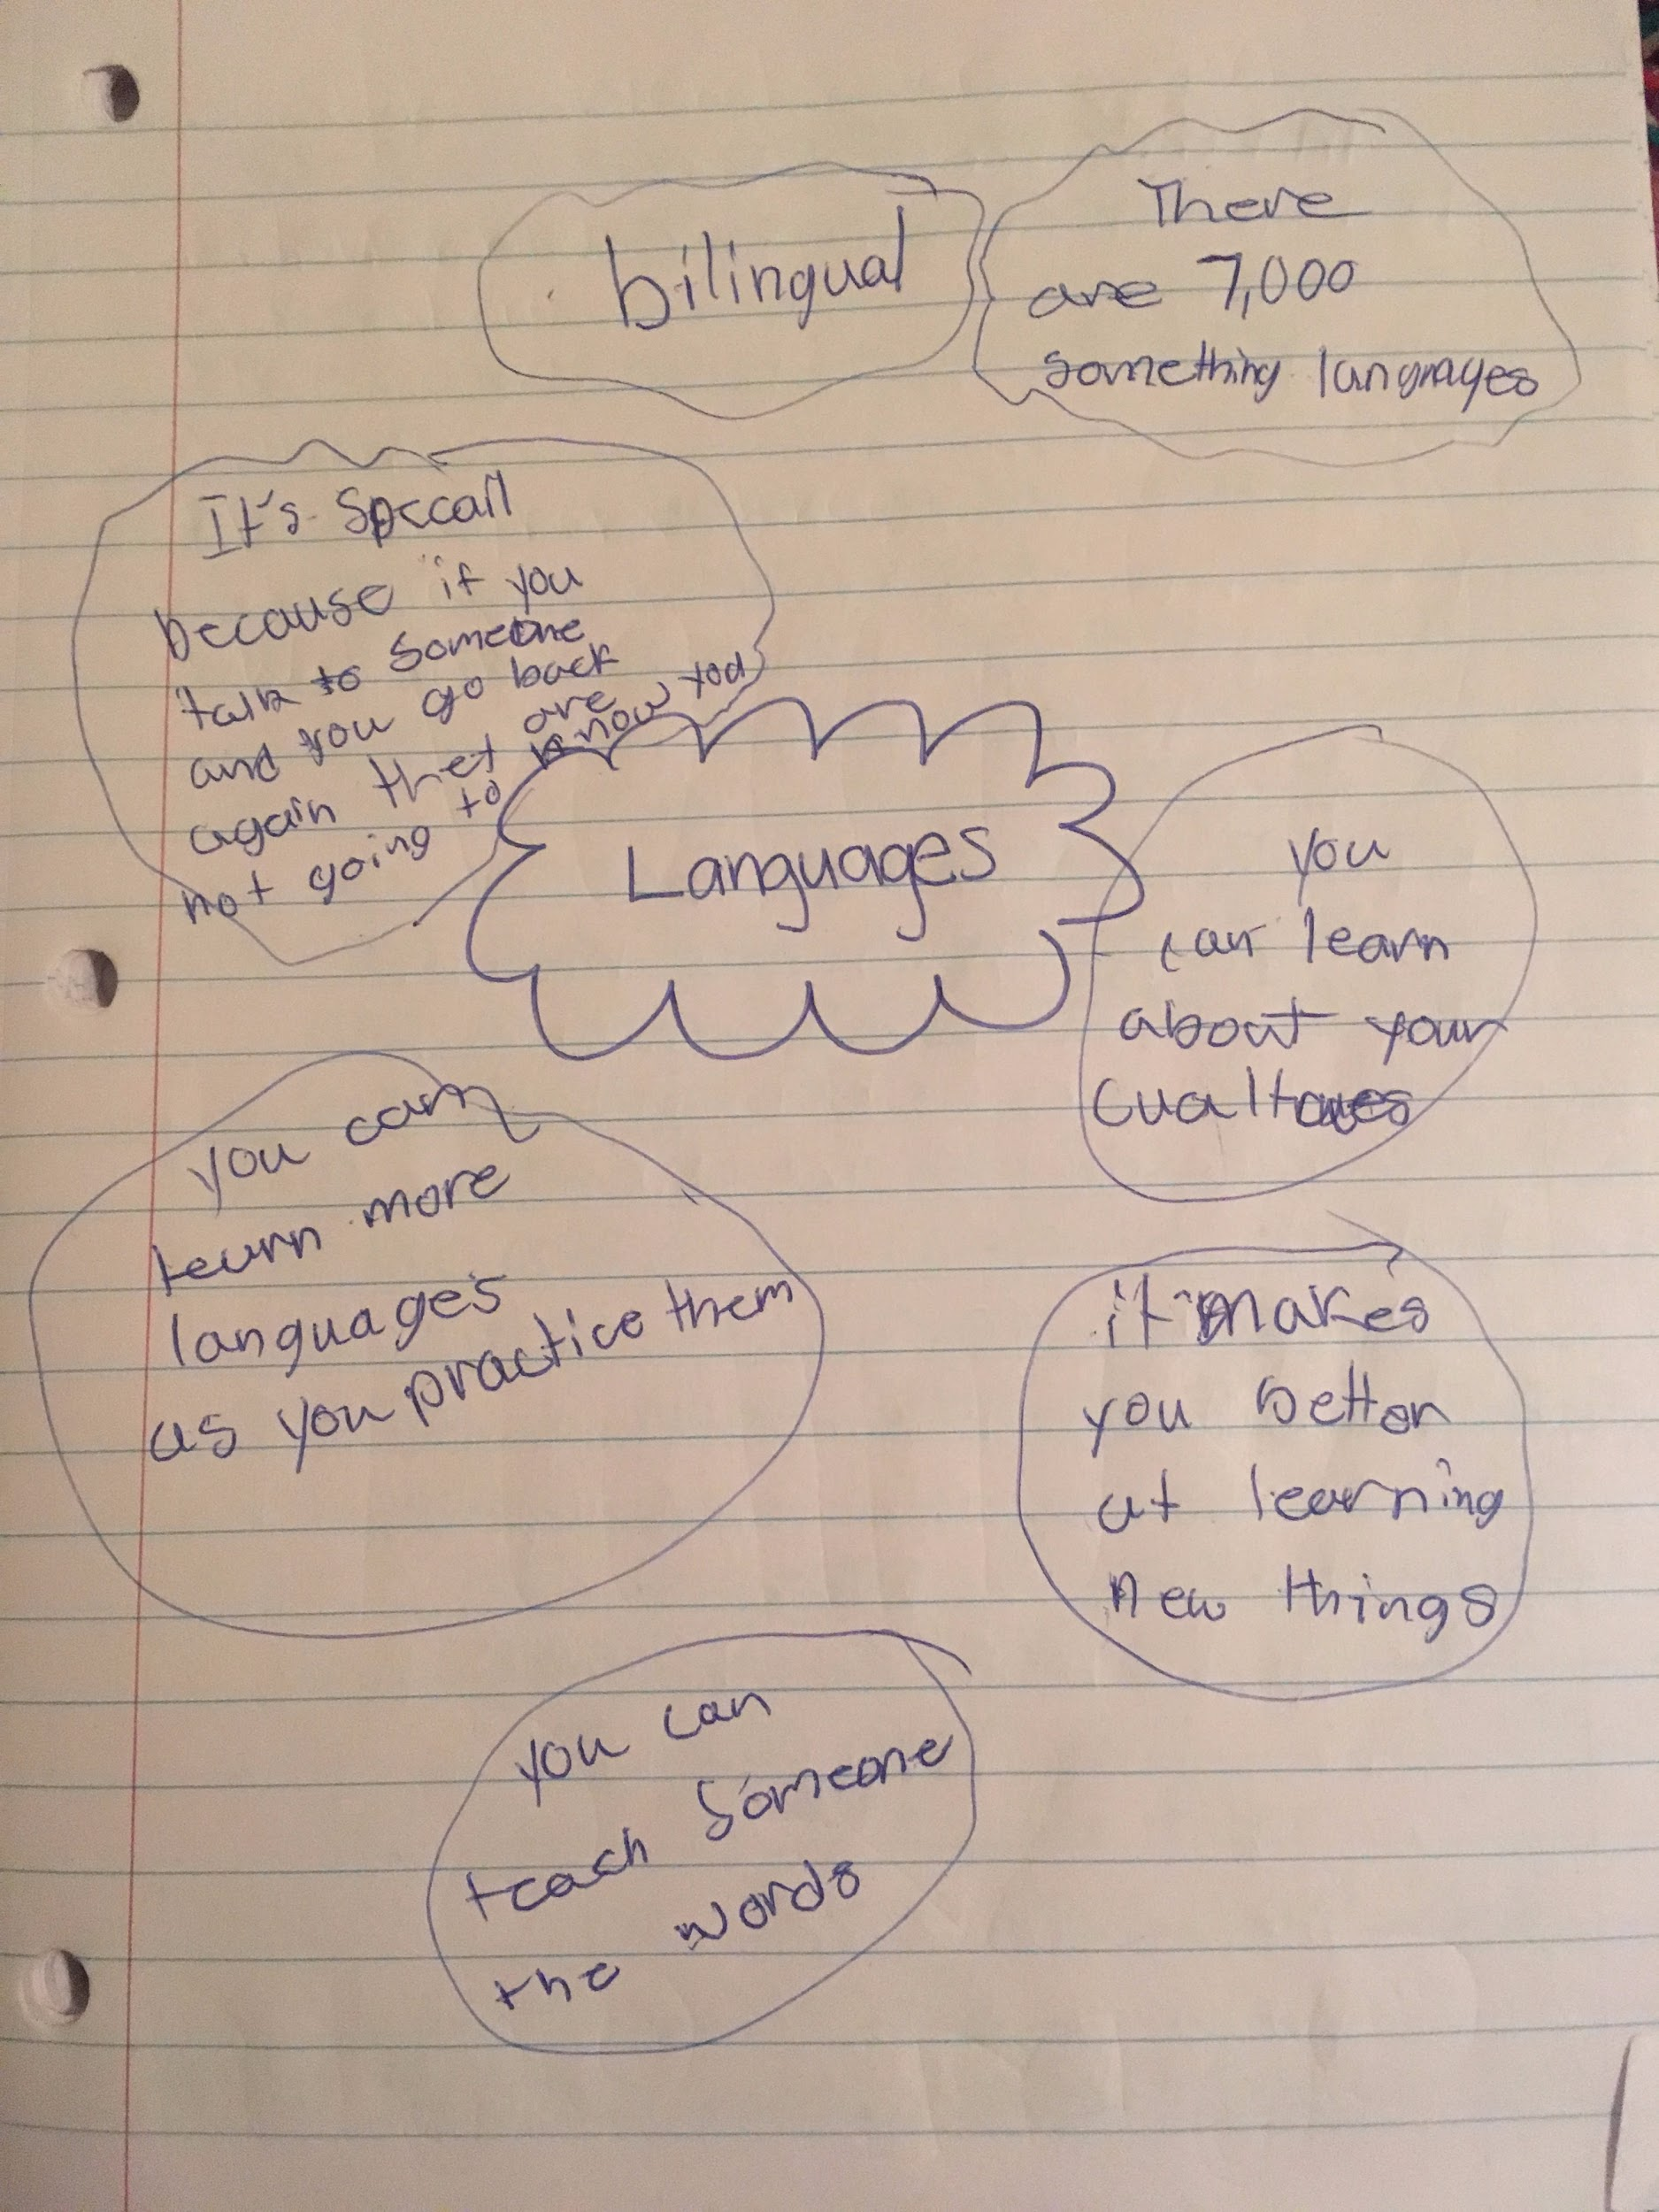 | - My buddy could point out the AAL being used in the book.  - My buddy could recognize some people in his life that used AAL. (Patricia)  - As a result of the teaching, he learned that you can actually translate between AAL and English to say the same thing in different ways.  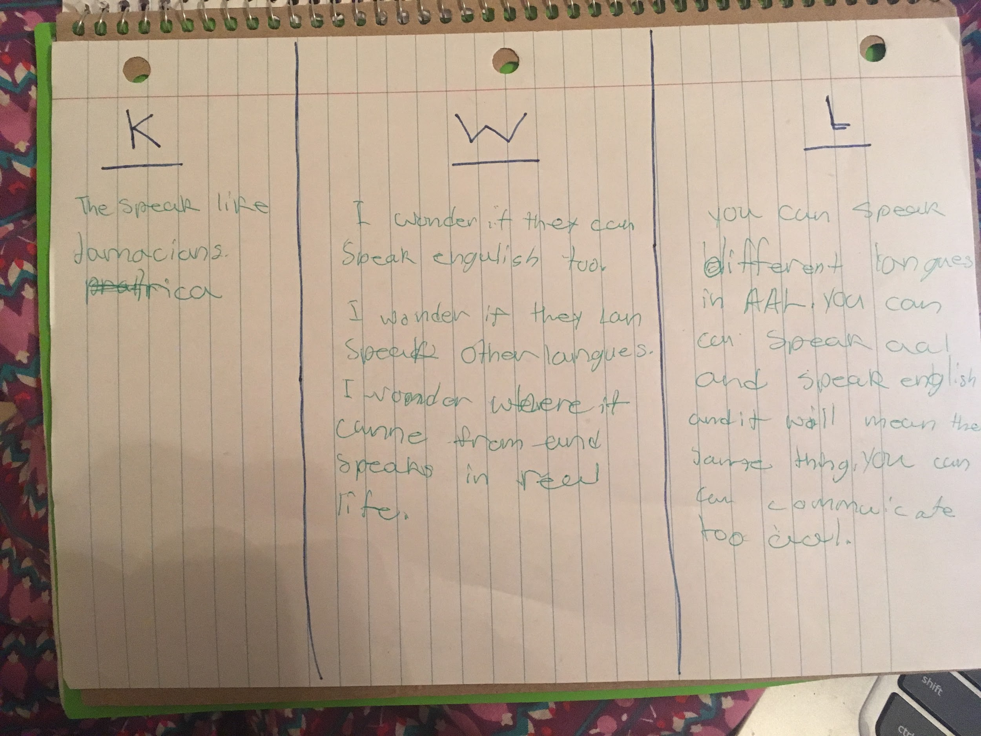 | - My buddy started to understand how to translate between AAL and Standardized English.  - He is able to fill out a contrastive analysis chart.  - My buddy is able to create writings in Standardized English and AAL AND translate those writings.  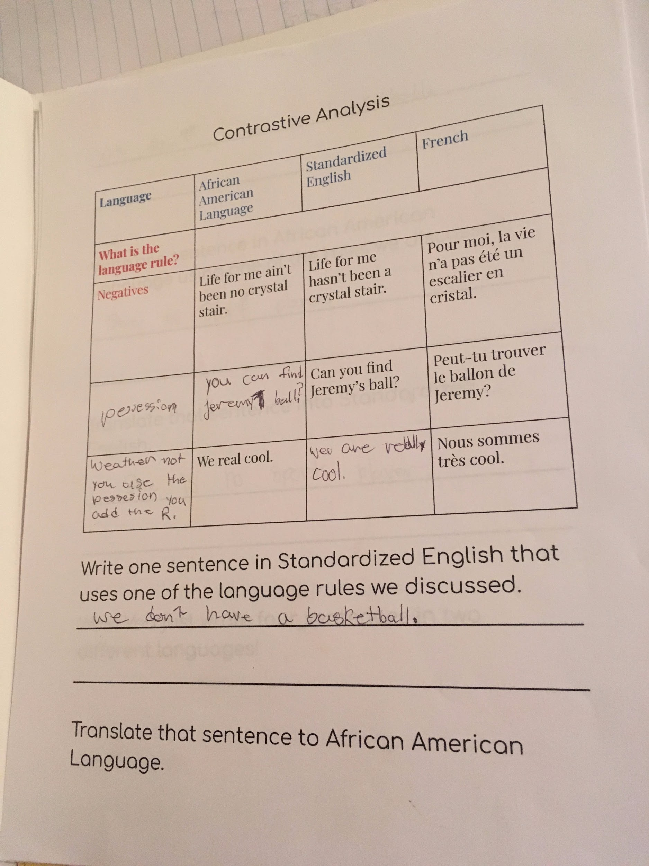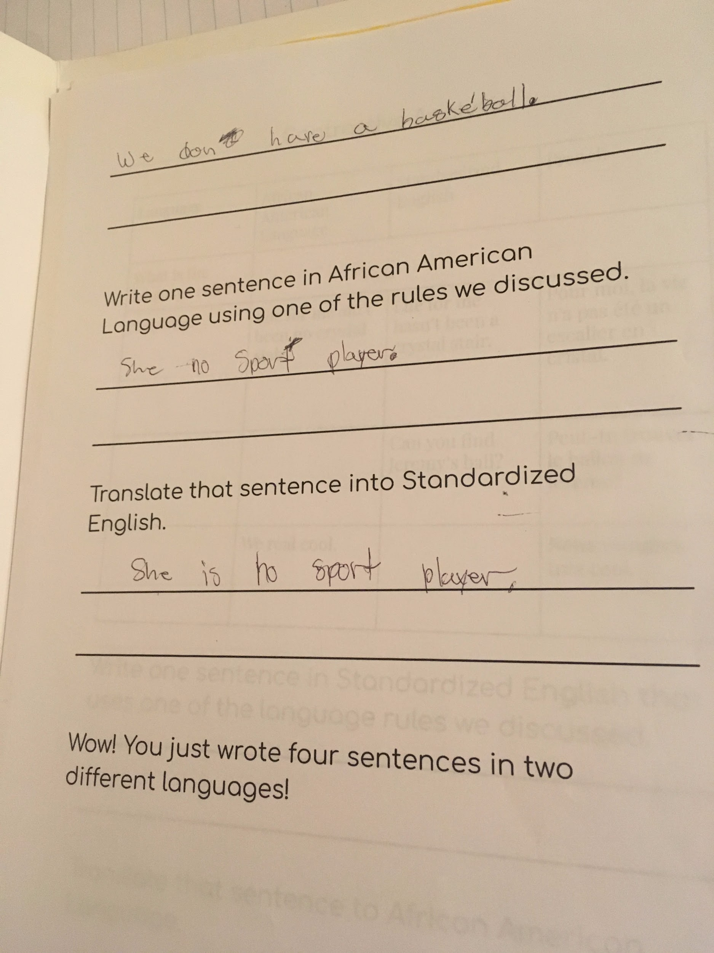
Reflection on Self: (what you did well, what you would do differently the next time). | - I was enthusiastic and that made my buddy enthusiastic about learning.  - I tried to provide as many examples as possible.  - If he wasn’t understanding something, I asked guiding questions to get him to deepen his thinking.  - Next time, I would not have opened with My Name is Yoon. He at first was really stuck on how Yoon was confused by having to move to a whole different culture and the physical move itself. I had to amend my questions to transition him to thinking more about languages themselves and how they help us be a part of multiple cultures rather than phsyical spaces.  - I should have include more examples of words from other languages. | - I would have planned the pacing better. I spent a lot of time giving background knowledge of AAL, and was starting to run out of time. I got so overwhelmed by that that I really started rushing through the rules that are important in AAL and the beginning of translations.  - Next time, I would just take a breath and take my time. I am going to be talking more about the rules in AAL next week, and when I look at this lesson overall, it is really important to spend some time going over some of the language structures of AAL so that the students that see it really start to understand the legitimacy of AAL!  - My buddy had a lot of good questions about AAL when we did the K-W-L chart! I really enjoyed that activity and would do it again next time.  - My buddy enjoyed learning the history of AAL and was engaged with the presentation! I don’t know if anyone has ever taught him about it before!  - I think a did a good job not reducing the continent of Africa to a country and not reducing the people of the continent of Africa to a single story. | - I think I did a good job going over the rules of AAL that we discussed. My buddy started to have an understanding of it from our lesson.  - I could tell my buddy liked this lesson - he really could see the beauty in AAL and was smiling knowing that he could translate!  - Honestly, Day 3 was not 100% revised by the time I taught it to my buddy. My powerpoint was MOSTLY finished being revised to be kid-friendly when I taught it to my buddy but afterwards I went through and made additional changes based on slides where he did not seem as interested or where he did not seem to understand as much. For example, I would have him re-read the poem after seeing the picture of Langson Hughes’ mother.  - My buddy pointed out the AAL in “Mother-to-Son” - he first pointed out where some of the words ending in “-ing” did not have the last consonant. I did not even go over that rule with him before we read it but I should have!

(PICTURES OF STUDENT ARTIFACTS LARGER BELOW)

