Lesson Plan One
1st grade
LESSON  PLAN COMPONENT | DAY ONE | DAY TWO | DAY THREE
Topic of Lesson and Curricular Structure (Contrastive Analysis: Read Aloud) | Contrastive Analysis: Beauty of Language | Contrastive Analysis: AAL, Spanish, and SE PowerPoint and Class book | Contrastive Analysis: Using SE, AAL, and Spanish and contrastive analysis chart
ELA Standards & Indicators Addressed (at least four) | SC ELA Grade 1- Standard 1: Formulate relevant, self-generated questions based on interests and/or needs that can be investigated. 1.1: Translate “wonderings” into questions that lead to group conversations, explorations, and investigations.  Standard 1: Interact with others to explore ideas and concepts, communicate meaning, and develop logical interpretations through collaborative conversations; build upon the ideas of others to clearly express one’s own views while respecting diverse perspectives. 1.1 Explore and create meaning through conversation, drama, questioning, and story-telling. | SC ELA Grade 1-  Standard 2: transact with texts to formulate questions, propose explanations, and consider alternative views and multiple perspectives. 2.1 Engage in daily exploration of texts to make connections to personal experience, other texts, or the environment.  Standard 10: Apply a range of strategies to determine and deepen the meaning of known, unknown, and multiple-meaning words, phrases, and jargon; acquire and use general academic and domain-specific vocabulary. 10.1: Ask and answer questions about known and unknown words.  Standard 5: Determine meaning and develop logical interpretations by making predictions, inferring, drawing conclusions, analyzing, synthesizing, providing evidence and investigating multiple interpretations. 5.1 Ask and answer who, what, when, where, why, and how questions to demonstrate understanding of a text; use key details to make inferences and draw conclusions in texts heard or read. | SC ELA Grade 1-  Standard 4: Synthesis integrated information to share learning and/or take action. 4.1 Draw conclusions from relationships and patterns discovered during the inquiry process.  Standard 3: Know and apply grade-level phonics and word analysis skills in decoding words. 3.1 Demonstrate the sound correspondence for common consonant blends and digraphs.
Goals (concepts to be taught) | I want my student(s) to understand that:  - All languages are beautiful and should be appreciated.  - Languages have similarities and differences  The student will be able to:  - Produce questions that are evident of deeper, critical thought on the topic(s) of language, bilingualism, multilingualism, translation, and linguicism  - Discuss the advantages of bi/multilingualism; cognitively, socially, and globally | I want my student(s) to understand that:  - Languages have similarities and differences  - SE, AAL, and Spanish all have special features that make them unique  The student will be able to:  - Explore and interact with different texts to formulate questions, propose explanations, and consider alternative views and multiple perspectives | I want my student(s) to understand that:  - Listening to, reading, and comprehending poems, written stories, songs, and oral histories of all three languages allows for the comparison between cultures  - Changing the way that one speaks is important in some settings  - Translating between languages is a necessary tool to have  The student will be able to:  - Translate between AAL, Spanish, and SE
Materials (list everything you need for the lesson) | - PowerPoint  - Poems, songs, histories embedded in PowerPoint  - Journal/paper  - pencils | - Be Boy Buzz  - Marisol McDonald Doesn’t Match/Marisol McDonald no combina  - PowerPoint  - Blank paper  - Markers/crayons/colored pencils | - Be Boy Buzz  - Marisol McDonald Doesn’t Match/Marisol McDonald no combina  - Chart to translate and compare between SE, AAL, and Spanish  - pencils  - White boards, markers, and erasers to practice with different groups of classmates  - Index cards with examples of SE, AAL, and Spanish
Guided Instruction (step-by-step, what you will say and do) | - Start by asking if the student knows how many languages are in the world  - Show map that shows different languages throughout the world  - Discuss terms that are used in the PowerPoint- language, bilingualism, multilingualism, translation, and linguicism  - Begin PowerPoint  - Have discussion on the importance of language in our world  - Have student write journal entries (or just write thoughts on paper if no journals) in their home language or the language that they are most comfortable using to document their understanding of language and its many different forms. This can be an overview of what they learned if the student wants it to be like that or it can be what language is to them and why it is important to them. | - Have a short recap of the lesson from yesterday, reminding the student the beauty of language and the terms that we use when discussing language  - Begin PowerPoint that has history and origins of AAL and Spanish, as well as why we should honor and appreciate all languages. This is where we will spend a majority of our time, talking about the different languages and the history of these languages and how they became so wide stream not only in the United States but in the world.  - Have a discussion on what they thought about the different languages that were discussed, as well as helping the student with speaking all three languages  - Pull out blank drawing paper for the student as well as crayons, colored pencils, and crayons  - Introduce the student to the task of drawing a “scene” from their lives where they have used their home language  - Can be a good or bad memory, doesn’t have to be them using the language but cannot be a made-up story  - If this were in a class, we would share our scenes and put them together to make a class book all about our languages | - Start class by reading aloud the book/ “scene” from your life that we made yesterday  - Go back over the key differences between AAL, SE, and Spanish  - Read Be Boy Buzz. Explore the aspects of AAL that are presented in the book.  - Read Marisol McDonald Doesn’t Match/Marisol McDonald no combina. Explore the differences in the book between the Spanish text and the English text.  - Have contrastive analysis charts that I have premade for student to start with independently  - Once they finish those, they can grab a partner and a white board and marker and eraser and practice writing examples in AAL, SE, and Spanish and translating each into a different language
Rationale: (How is this lesson critical to building your student(s)’ linguistic knowledge and appreciation?) | This lesson teaches that language is a very important aspect of each and every person’s sense of self. It highlights all of the benefits of bi and multilingualism, the millions of languages that are spoken in the world, and why it is important to appreciate the home language of each student. The lesson will also teach that being multilingual is beneficial for you in many different ways. Paradowski (2017) said “multilingualism is the natural potential available to every normal human being rather than an unusual exception”. This lesson will teach students that knowing and learning more than one language equips them with tools that no one can ever take away from them. Sizer (2011) said that “just as crossword puzzles and learning a musical instrument have been shown to boost the brain’s “cognitive reserves,” so too does learning more than one language. While cognitive reserves won’t prevent dementia entirely, the study concluded that they may keep Alzheimer’s at bay by “compensat[ing] for the accumulation of amyloid and other brain pathologies”. Being multilingual allows for people to “…understand and appreciate people of other countries, thereby lessening racism, xenophobia, and intolerance (Carpenter & Torney 1974), as the learning of a new language usually brings with it a revelation of a new culture” (Paradowski, 2017). In all, I want my students to recognize that “being bilingual or multilingual can only be considered a good thing. The ability to travel seamlessly in another country; to interact with people you wouldn’t otherwise be able to communicate with; to really understand and immerse yourself in another culture, whether it be your own or another’s; and on the most trivial level, to order off a menu and truly know what you’re ordering” (Chan, 2014) | On the second day, this lesson will bring attention to the three languages that I chose to focus on; AAL, Spanish, and English. By having the rich history of both AAL and Spanish taught to them the students will be learning more about themselves while also learning about a different culture and how differences are beautiful and similarities that bring people together despite these differences can prevail. Introducing the history of AAL and the languages and traditions of the west coast of Africa before teaching about slavery allows my students to see that Africa was, and is, a continent full of wonderful people, resources and a history that is closely related to their own culture. Including the taking of enslaved peoples from this west coast and showing the route that they were taken on allows for students to connect and to see their heritage. This is a great place to tie in language and multilingualism because “to speak Ebonics is to assume the cultural legacy of U.S. slave descendants of African origin. To speak Ebonics is to assert the power of this tradition in the quest to resolve the unfinished business of being African in America” (Smitherman, 2014, p. 118). Having the background knowledge to understand why the language is so important to the people that speak it is an essential point for this lesson. It allows students to use this background knowledge when reading multilingual texts to question what they are reading, propose explanations, and consider alternative views and experiences. Boutte and Johnson (2012) said that “effective teachers build on children’s language skills communicating respect for the children, their families, and their communities” (p. 140). | On the third day, the students will be translating between the three languages as well as learning and practicing some code-switching skills. These are all important because the traditional teaching approach to different languages in the American classroom have typically been correction or even deletion but “instead, the goal is to help children translate from their home language to school language at appropriate times. Books written in AAL can be ‘‘translated’’ by children to SE and vice versa. It is important to translate AAL into SE and SE into AAL” (Boutte and Johnson, 2012, p. 138). A key component of this day will be understanding that students are not “correcting” but instead translating or switching to the most appropriate for the scenario, not meaning that the way someone says something is ever wrong. Wheeler and Swords (2004) say that “with a linguistically informed approach to language arts, you will be able to move away from seeing your students’ writing as deficient, filled with errors, and in need of correction. In its place, we will show you how to draw on your students’ strengths in their home language as a springboard from which they can reach Standard English” (p. 11). This is a serious evaluation of the teacher and their viewpoint on language and instilling this viewpoint of language to the students at such a young age could truly allow for their understanding of language to always be accepting and varied instead of the “norm” (at least in the states) of Standardized English is the only proper language that we should speak. This not only creates deficit views on language but has the potential to create deficit views on people based on their language. The students will also understand that sometimes translating things from one language to another may take away some of the meaning because sometimes there are just not the right words in different languages. By the end of this lesson, the students will see the beauty of bi and multilingual people, themselves as linguists, a basic understanding of the history of the three languages, and why it is important to appreciate and honor all languages and dialects that are found in the word around us.
Assessment (How will you find out if the students meet your Goals?) | Review journal entries and check for understanding in their writings. | Do the students scenes actually use their home language?  Is the classroom book all about the beauty and the diversity of language? | Look over their individual charts to see if they understand the translation concept.  Do the student questions during the two read alouds show critical deeper thinking?
Reflection on Students: (what do your students understand and what can they do as a result of your teaching? – include evidence, digital photos attached to this reflection electronically) | My reading buddy, while a bit apprehensive at first, really excelled at this lesson. She understood that knowing different languages helped people in a variety of different ways, including travelling and was very interested in knowing that people who knew more languages were “smarter” as I was putting it, meaning that they could access the information in their brains faster than people who only spoke one languages could. She was very interested in the globe and finding the continent of Africa in relation to New York state, where she is from. I really focused on the fact that she was multilingual because she could speak all three languages that we would be talking about in the next two lessons. She said something that was really beautiful when I was asking her about the benefits of being bi/multilingual. She was talking about being able to travel and go different places and live how you wanted to and said that, “Dreams are not just for sleeping, they are for believing.” My reading buddy can relate to terms like bilingual and multilingual and knows the importance of translating between languages.  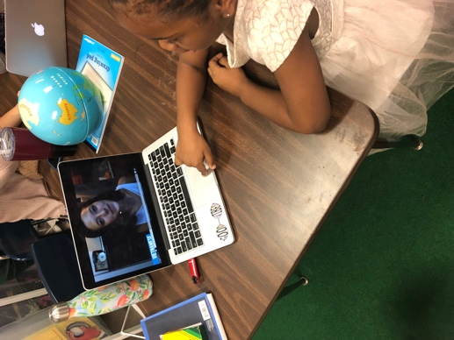 | My buddy was really intrigued by the three different languages that we talked about today. I made sure to constantly congratulate and praise her for the translating between languages that we started. She understood the difference between continents (Africa, Europe, North America) and countries (Sierra Leone, USA, Spain) and enjoyed learning about the different languages in each country and the variations of those languages that we speak today. As a result of this lesson, my buddy can find and determine meaning in her own terms of different structures of language in ALL and Spanish, including the habitual B and the double negative. My buddy drew her “scene” by drawing things that she knew came from different cultures that she had experienced in her life. She drew a dragon to represent the Chinese culture and said that could be a fourth langue that we could learn about. 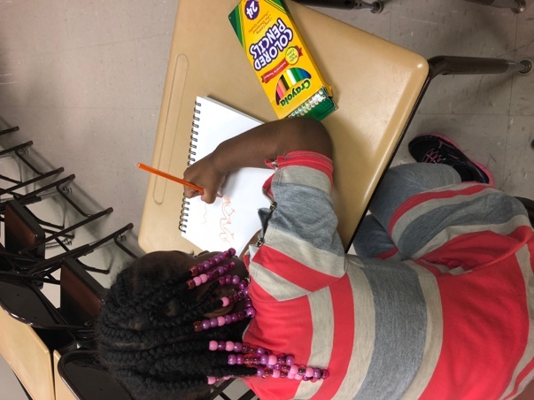  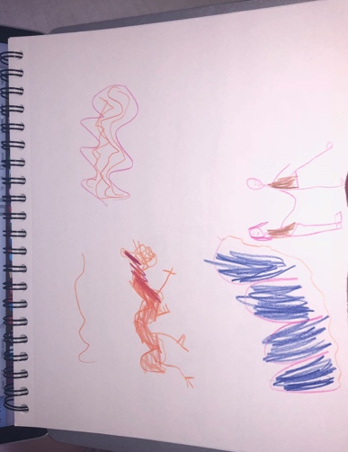 | My buddy understands that all languages are important and valid and translating between languages provides connections and opportunities for personal growth. She also knows that even though she speaks standardized English and AAL most often, she can still speak Spanish and she really enjoys speaking Spanish. On this day, we really focused on using the two books and examples from them to discuss and practice writing sentences in the three different languages. As a result of my teaching, my buddy can translate both on and off paper between AAL and Standardized English. She also now knows that she is multilingual and that it very special and it is beneficial to her. At the end of my lesson, I made sure to do a sort of recap of my three days so that she could really connect with what we had learned. 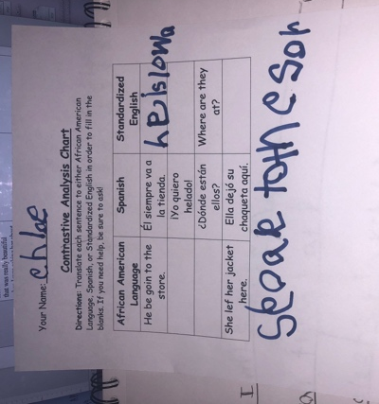  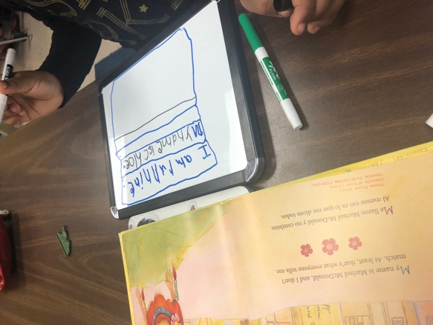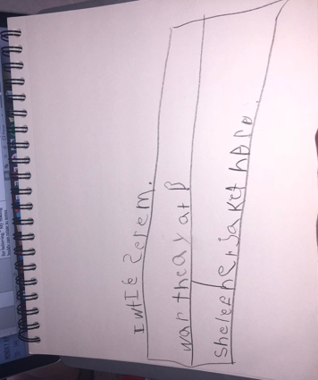  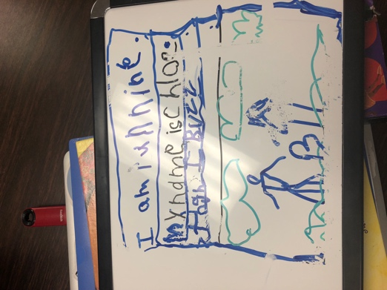
Reflection on Self: (what you did well, what you would do differently the next time). | I think that next time I would want to have my computer set up on something so that it could reduce the distraction. My buddy was very focused on moving the mouse around that at times I had to repeat myself multiple times to get her back on track. I think that my PowerPoint was very beneficial, and the video at the beginning where people were saying the greeting in their language was a great starting point. I really spent today talking with my buddy and explaining the different terms that would be important during our next two lessons and I think that I did a good job on this. I didn’t make things “dumbed down” but my buddy was not frustrated by trying to understand me. | I think that on this day I did a really good job at explaining things, so they were not confusing or frightening for my buddy. I reinforced that there were many languages and cultures and brilliant people in Africa on the West Coast and then asked if she had ever heard of slavery. She said she had and I went into explaining that there were doctors, lawyers, teachers, and many other brilliant people who were taken away and that even though they were taken away, their language or parts of their language stayed with them and that some people still use the languages today. She was very interested in this I think because she had only ever heard slavery to be a bad thing that happened a long time ago, and while this is true, it is important to teach that the people who were enslaved were brilliant and brought many aspects of cultures that we still see today with them. Next time I would try to have videos or interactive opportunities because I noticed my buddy getting a bit bored towards the last 5 minutes of my lesson. I think that by having her draw a scene from her life using her language she really had to think critically about what she did a t home and school and how it related to what we were talking about, which was one of my main goals. | Today I was a bit nervous because I didn’t have a PowerPoint, so I thought my buddy might be bored but she really enjoyed both of the books that we read so I think that was a great attention grabber. She also enjoyed comparing the three languages used in both books and writing her own sentences on the white board. I did well with my book choice because like I said she really enjoyed them. Something that I would do differently next time would be to have a different chart. I would like to have a blank chart and have her come up with what we translated, although I can see where this would be difficult too since I don’t know much Spanish and not knowing the translation ahead of time could be problematic.

