Contrastive Analysis Lesson Plan

LESSON  PLAN COMPONENT | DAY ONE | DAY TWO | DAY THREE
Topic of Lesson and Curricular Structure (Contrastive Analysis: Read Aloud) | Celebration of Languages: PowerPoint | Introduction of AAL: PowerPoint/Read Aloud | Contrastive Analysis: PowerPoint/Read Aloud
ELA Standards & Indicators Addressed  (at least four) | South Carolina College and Career Ready ELA Standards and Indicators for Kindergarten  Inquiry-Based Literacy Standard 2: Transact with texts to formulate questions, propose explanations, and consider alternative views and multiple perspectives.  2.1 With guidance and support, engage in daily explorations of texts to make connections to personal experiences, other texts, or the environment.  Inquiry-Based Literacy Standard 3: Construct knowledge, applying disciplinary concepts and tools, to build deeper understanding of the world through exploration, collaboration, and analysis.  3.1 With guidance and support, develop a plan of action for collecting information from multiple sources through play, sensory observation, texts, websites, and conversations with adults/peers.  3.2 With guidance and support, select information, revise ideas, and record and communicate findings.  Reading – Literary Text Standard 7: Analyze the relationship among ideas, themes, or topics in multiple media, formats, and in visual, auditory, and kinesthetic modalities.  7.2 Read or listen closely to compare familiar texts.  South Carolina Social Studies Standard K-1: The student will demonstrate an understanding of his or her surroundings.  Enduring Understanding:  Maps and other geographic representations can communicate information about the location and features of one’s surroundings. To access and utilize geographic information efficiently, effectively, and accurately, the student will utilize the knowledge and skills set forth in the following indicators:  K-1.3 Identify his or her personal connections to places, including home, school, neighborhood, and city or town. | South Carolina College and Career Ready Standards and Indicators for Kindergarten  Inquiry-Based Literacy Standard 2: Transact with texts to formulate questions, propose explanations, and consider alternative views and multiple perspectives.  2.1 With guidance and support, engage in daily explorations of texts to make connections to personal experiences, other texts, or the environment.  Inquiry-Based Literacy Standard 3: Construct knowledge, applying disciplinary concepts and tools, to build deeper understanding of the world through exploration, collaboration, and analysis.  3.1 With guidance and support, develop a plan of action for collecting information from multiple sources through play, sensory observation, texts, websites, and conversations with adults/peers.  3.2 With guidance and support, select information, revise ideas, and record and communicate findings.  South Carolina Social Studies Standard K-1: The student will demonstrate an understanding of his or her surroundings.  Enduring Understanding:  Maps and other geographic representations can communicate information about the location and features of one’s surroundings. To access and utilize geographic information efficiently, effectively, and accurately, the student will utilize the knowledge and skills set forth in the following indicators:  K-1.3 Identify his or her personal connections to places, including home, school, neighborhood, and city or town. | South Carolina College and Career Ready Standards and Indicators for Kindergarten  Inquiry-Based Literacy Standard 2: Transact with texts to formulate questions, propose explanations, and consider alternative views and multiple perspectives.  2.1 With guidance and support, engage in daily explorations of texts to make connections to personal experiences, other texts, or the environment.  Inquiry-Based Literacy Standard 3: Construct knowledge, applying disciplinary concepts and tools, to build deeper understanding of the world through exploration, collaboration, and analysis.  3.1 With guidance and support, develop a plan of action for collecting information from multiple sources through play, sensory observation, texts, websites, and conversations with adults/peers.  3.2 With guidance and support, select information, revise ideas, and record and communicate findings.  South Carolina Social Studies Standard K-1: The student will demonstrate an understanding of his or her surroundings.  Enduring Understanding:  Maps and other geographic representations can communicate information about the location and features of one’s surroundings. To access and utilize geographic information efficiently, effectively, and accurately, the student will utilize the knowledge and skills set forth in the following indicators:  K-1.3 Identify his or her personal connections to places, including home, school, neighborhood, and city or town
Goals  (concepts to be taught) | The student will be able to:  - List at least five (5) different languages spoken in the United States and South Carolina  - Describe the advantages of multilingualism  - Find the continent of North America on a map of the world  - Find the country of the United States of America on a map of the world  - Find the state of South Carolina on a map of the United States  - Relate any personal experiences to multilingualism | The student will be able to:  - Find the continent of Africa on a map of the world  - Describe what it means for a person to code-switch  - Write how many languages are spoken in Africa  - Relate any personal experiences to AAL, Spanish, or any of the text/resources | The student will be able to:  - Describe two rules of African American Language (AAL)  - Find rules of African American Language in Flossie & the Fox  - Relate rules of AAL to Standardized English and Spanish  - Write a multilingual text using African American Language rules
Materials  (list everything you need for the lesson) | - Laptop  - Day 1 PowerPoint  - Die Kleine Raupe Nimmersatt by Eric Carle Read Aloud Video – 6:44 (German) (https://www.youtube.com/watch?v=VvS4-92ZP6Y)  - 好餓的毛毛蟲 by Eric Carle Read Aloud in Chinese Video – 3:50 (https://www.youtube.com/watch?v=tT9wnGRvQZc)  - La Oruga Muy Hambrienta by Eric Carle Read Aloud Video – 3:56 (Spanish) (https://www.youtube.com/watch?v=0Xji5krOhTI)  - La Chenille Qui Fait Des Trous by Eric Carle Read Aloud Video – 3:38 (French) (https://www.youtube.com/watch?v=bb2sJhfNYi4)  - Day 1 Assessment Sheet  - Pencil | - Laptop  - Day 2 PowerPoint  - Code-Switching Video – 3:54 (https://www.youtube.com/watch?time_continue=12&v=VpLQmyS7-jw)  - Day 2 Assessment Sheet  - Pencil  - Be Boy Buzz by Bell Hooks and Chris Raschka | - Laptop  - Day 3 PowerPoint  - Day 3 Assessment Book  - Pencil  - Markers  - Flossie & the Fox by Patricia C. McKissack
Guided Instruction  (step-by-step, what you will say and do) | - T: “Hello Olivia! Today we are going to learn about the many beautiful languages that people speak around the world and right here in South Carolina. Can you name any languages that you know?”  - Listen to Olivia’s responses allowing wait time if necessary.  - Start Slide Show  - T: “We live in a world full of beautiful languages! Let’s see how people say hello around the world. They say Bonjour in French, Hola in Spanish, Hello in English, Guten Tag in German, Ciao in Italian, Namaste in Hindi, and Chaírete in Greek. Did you know there were 6,909 spoken languages?”  - T: “Do you know where we live on this map?”  - Wait for response  - T: “We live on the continent of North America. In the country of the United States of America where people speak over 350 languages! In the state of South Carolina. Some people even speak two or three or more languages! This is called bilingualism or multilingualism.”  - T: “When we can speak more than one language, we have a larger vocabulary, have sharper memories, become better listeners, and have flexible minds.”  - T: “So a couple weeks ago we read The Very Hungry Caterpillar by Eric Carle. Let’s listen to the same story in some new languages.”  - Play German, Chinese, Spanish, and French Videos  - T: “Aren’t they all beautiful! So, let’s see what you learned today.”  - Ask assessment questions and record Olivia’s answers.  - T: “I hope you enjoyed our time together! I will see you next week!” | - T: “Hello Olivia! Today we are going to learn about another beautiful language that is spoken right here in South Carolina! It’s called African American Language!”  - T: “It traveled all the way from the west coast of the continent of Africa to the east coast of the country of the United States of America. There are 54 different countries in Africa and the people speak over 1500 different languages.  - T: “The people of Africa were smart and beautiful. They were scientists, mathematicians, and artists, but something sad happened. They were stolen from their country and brought to the United States where they were enslaved. When this happened, they were not allowed to use their language. In order to communicate, they blended their language with Standard English and has evolved to what we now call African American Language.”  - T: “When people switch from one language to another in different settings it is called code-switching.”  - T: “Now, let’s listen to Be, Boy, Buzz by Bell Hooks and Chris Raschka.”  - Read book  - T: “So this book has examples of African American language! Let’s see two examples.”  - T: “Now let’s see what you know!”  - Read each question out loud and allow wait time for her to answer and write.  - T: “I hope you enjoyed our time together! I will see you next week!” | - T: “Hello Olivia! Today we are going to use all of the knowledge we have gained from our other lessons!”  - T: “I brought an awesome book that we are going to read today that has many examples of African American Language!”  - Read book  - T: “Now we are going to talk about some rules that are associated with African American Language! The first rule is called the habitual be. This is used when someone wants to express something that happens or occurs all the time. An example from the book would be when Flossie’s mom said ‘Chile, a fox be just a fox.’ In Standard English, it would sound like this ‘Child, a fox is always a fox.’ and in Spanish it would sound like this ‘El niño, un zorro es siempre un zorro.’”  - Repeat with slide 5  - Repeat with slide 6  - Repeat with slide 7  - “Now we are going to write a book! I’ll let you think about what you want to write. I’ll let you decorate the cover while you’re thinking.”  - Make markers and pencil available and assist when needed  - T: “This looks great! I hope you enjoyed our time together! I will see you next week!”
Rationale  (how is this lesson critical to building your student(s)’ linguistic knowledge and appreciation?) | This lesson will begin to lay the foundation that there are many beautiful languages spoken here in South Carolina and abroad.  - Although these languages sound different there are many similarities. Souto-Manning and Martell states, “it is essential to make room for talk in our classrooms-not only for the sake of oral language development, but for the sake of learning; after all, learning is mediated by and enhanced through talk. Doing so can socialize children into multiple culturally situated pragmatics, varying phonologically and semantic rules, and myriad syntactic structures” (2016).  - Chan stated, "people who spoke two or more languages had greater cognitive abilities - particularly in general intelligence and reading - from their baseline, compared with those who only spoke one language”. (p. 2)  Rationale Resources:  - Chan, Amanda. Seven Reasons Why It’s Good to Speak Another Language.  - Souto-Manning, M. & Martell, J. (2016). Reading, Writing, and Talk: Inclusive Teaching Strategies for Diverse Learners, K-2. New York: Teachers College Press. | This lesson expands on knowledge gained from Day 1 about the beauty of languages by introducing two specific languages and comparing them to each other and Standardized English.  - "There is a popular believe that dialects are simply corruptions of 'real' or 'good' English that reflects basic ignorance of well-known grammar rules. But the truth is that dialect structures are in themselves quite natural and neutral. Their social impact comes solely from their association with different groups in society." (p. 2)  - “Acknowledging an overlap between AAL and SE while also accepting that AAL is distinct from SE leads to the realization that children who speck both AAL and SE are dual language learners. Hence, AAL is more than a ‘pass-through language, only to be used to get to SE’. Although for the most part, AAL speakers need to learn SE to be successful in US society children’s linguistic fluency in both AAL and SE should be encouraged and honored.” (p. 39)  Rationale Resources:  - Wolfram, Walt. Everyone Has An Accent.  - Four Things to Remember about AAL by Boutte, Gloria (2015) | This lesson culminates all of the knowledge gained from Day 1 and 2 about multilingualism, AAL, and draws on her knowledge of Spanish.  - “Contrary to pervasive deficit perspectives and narratives about AAL and ongoing microaggressions (daily cultural assaults) against it in school, our 2-year study of our granddaughters’ (Janiyah and Jaliyah) language revealed that the girls sometimes viewed MAE/SE as bothersome and tedious; hence, there were times when they actively resisted it. At other times, they embraced it, when they determined that using SE instead of AAL made sense.” (2016)  - “One research study of African American university students demonstrated that contrastive analysis resulted in 59.3 percent fewer AAL features in writing, as opposed to 8.5 percent fewer AAL features when traditional methods were used. Other studies with elementary students have also demonstrated that contrastive analysis is effective for teaching AAL speakers to add on SE, as well as improving reading and writing outcomes for the students.” (2016)  Rationale Resources:  - Educating African American Students: And How Are the Children? by Boutte, Gloria S. (2016)
Assessment  (how will you find out if the students meet your Goals?) | Ask the following questions at the end of the lesson and allow Olivia to write answers on assessment worksheet:  - Can you name some of the languages we heard today?  - Can you tell me one good thing that happens when you can speak more than one language?  - What continent do we live in? Can you circle it one the map below?  - What country do we live in? Can you circle it on the map below?  - Do you know anyone that speaks a language in addition to English? | Ask the following questions at the end of the lesson and allow Olivia to write answers on assessment worksheet:  - Where is the continent of Africa? Can you circle it on the map below?  - Where is the continent of North America (where we live!)? Can you circle it on the map below?  - How many languages are spoken on the continent of Africa?  - Can you tell me what it means when a person code-switches?  - What language is shown below? Please choose your answer from the list below and write in the box above each sentence. | Olivia will write a book about herself in AAL, Standardized English, and Spanish. I will provide assistant if she needs it with the Spanish translations.
Reflection on Students  (what do your students understand and what can they do as a result of your teaching? – include evidence, digital photos attached to this reflection electronically) | After teaching the lesson, I gave Olivia the assessment sheet:  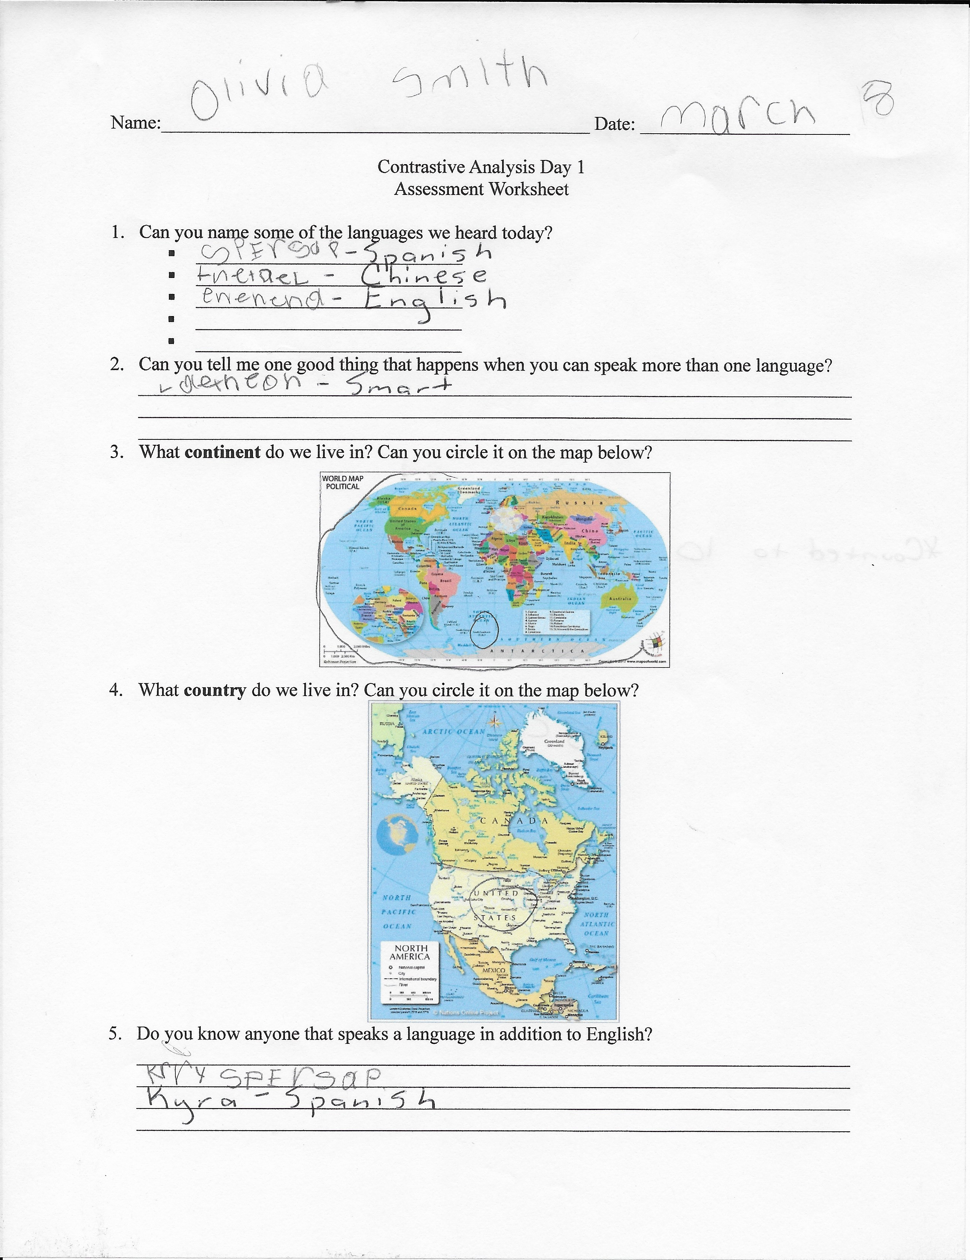  She named three languages that we discussed in the PowerPoint but was not able to identity North America on a map of the world or the country of the United States of America. When asked about languages she named Spanish, immediately, as she goes to a Spanish class each week, and she counted to ten in Spanish. I will use Spanish as my third language when completing my contrastive analysis lesson. | After teaching the lesson, I gave Olivia the assessment sheet:  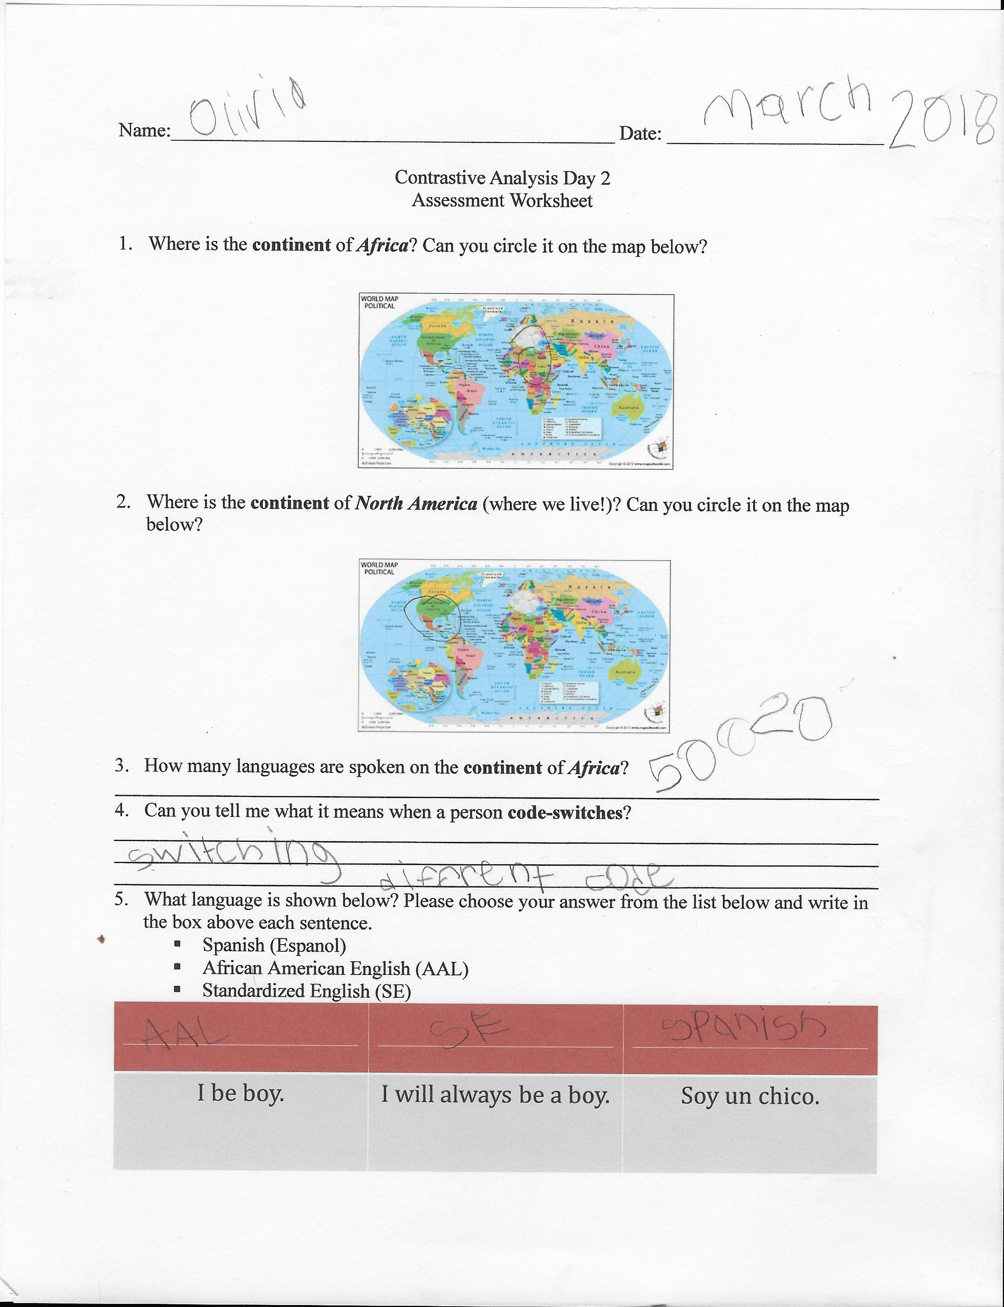  After teaching the lesson Olivia was able to identify the differences between AAL, SE, and Spanish. She correctly chose the continent of Africa and North America because I revisited their location at the beginning of this lesson. When asked about the amount of languages she said the right number but forgot to write the 1 at the beginning and added a 2 and 0. While teaching this lesson Olivia was pretty engaged and seemed to be interested in the lesson. She enjoyed the book and even read a couple pages herself. | After teaching the lesson, Olivia wrote the book below:  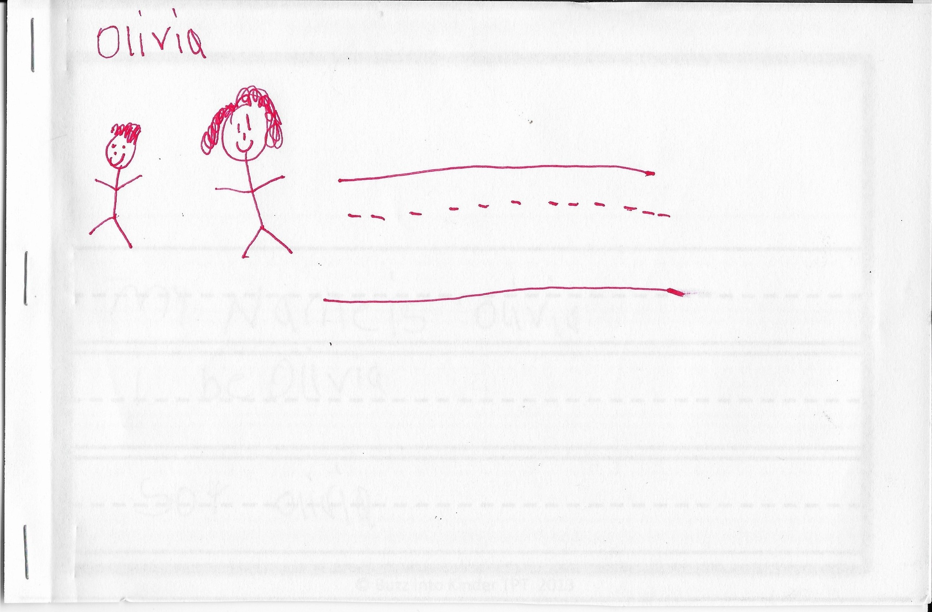  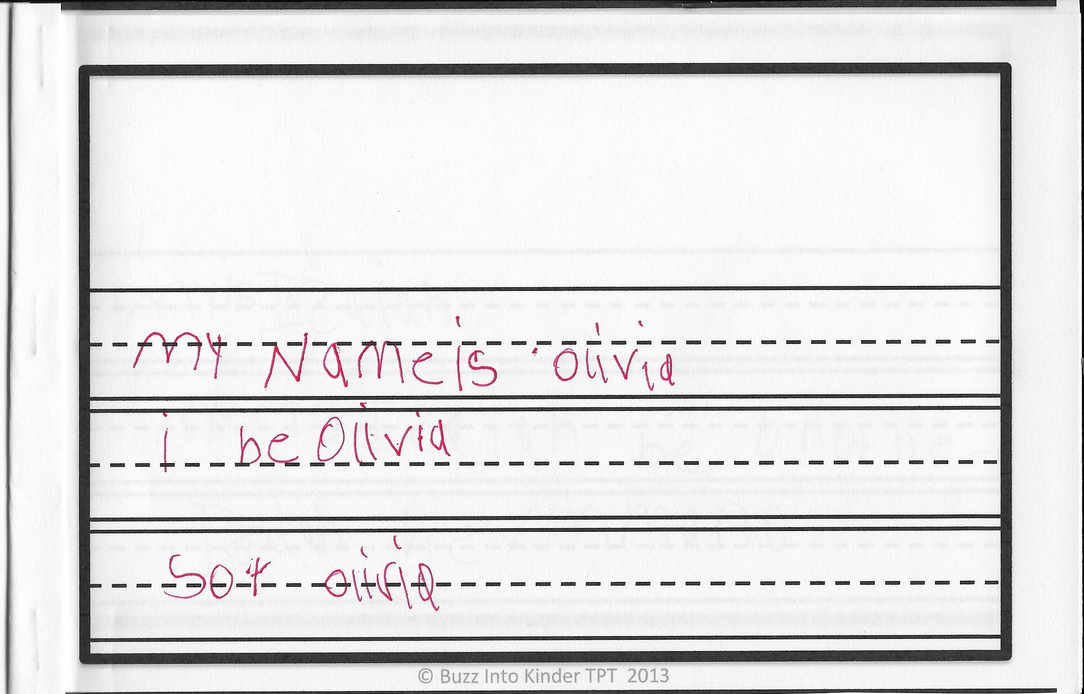  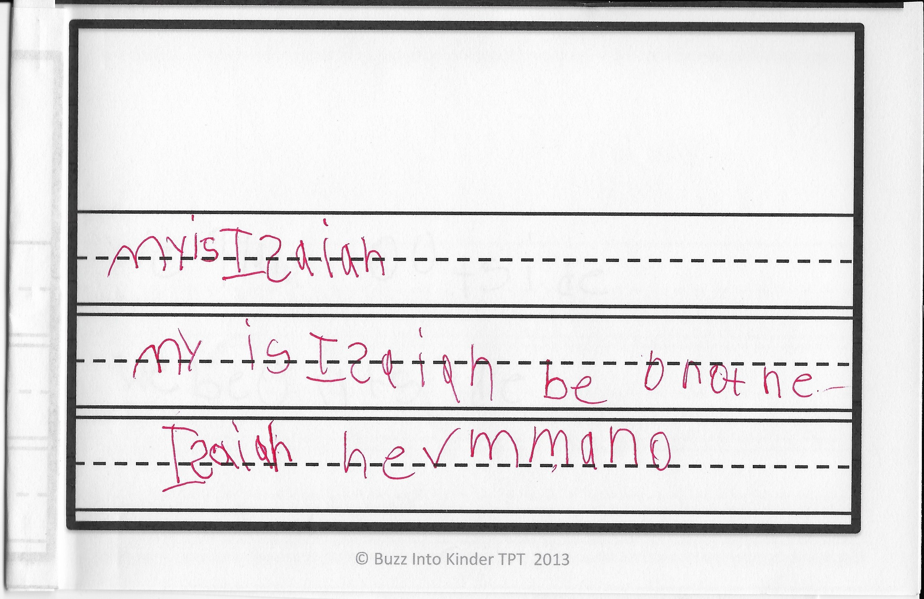  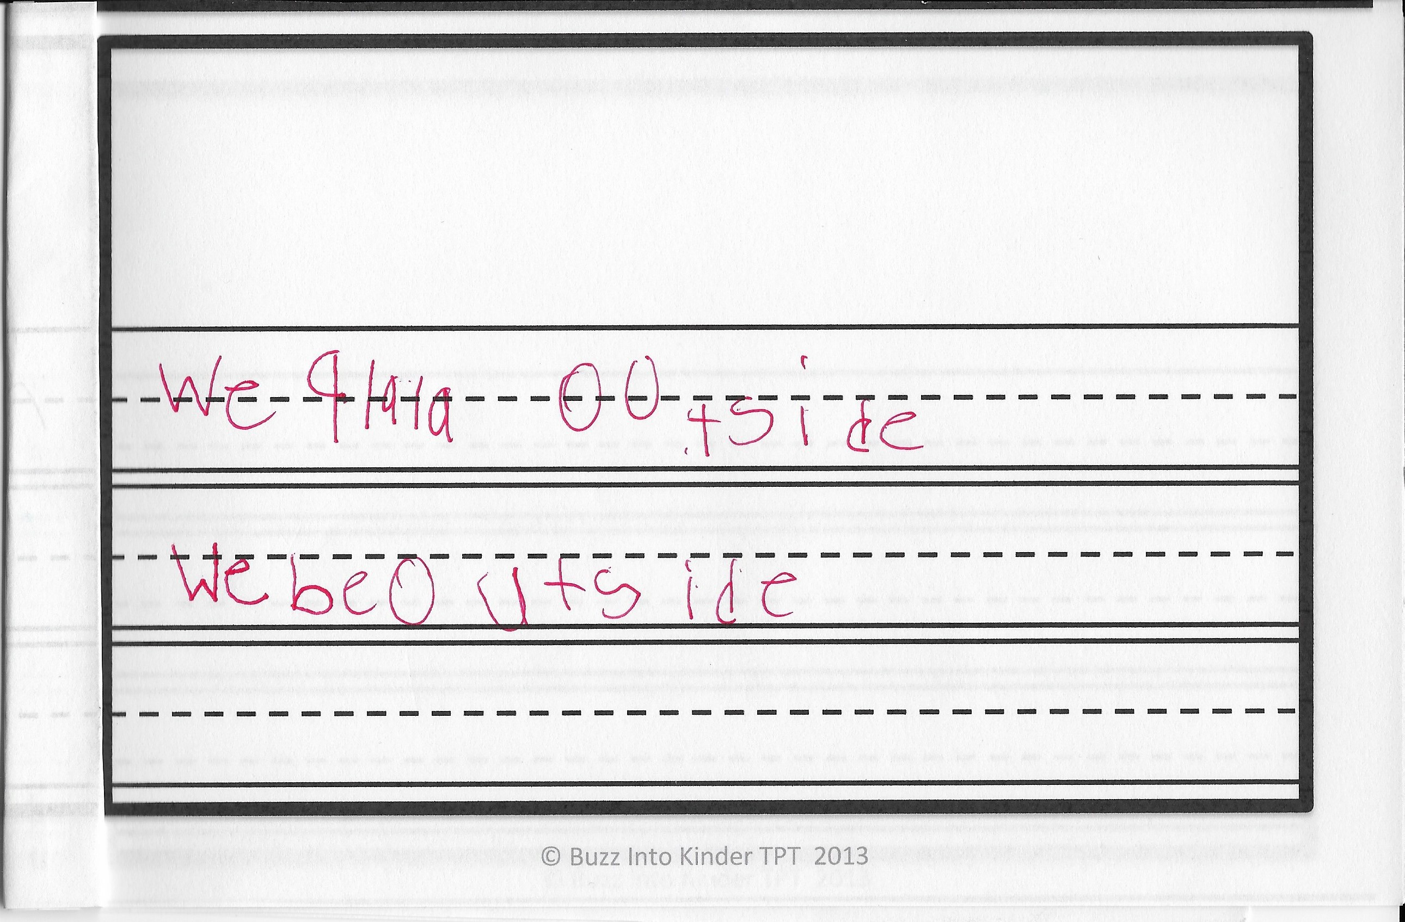  Her book was about her. She introduced herself on the first page, she introduced her brother on the second page, and she described her cover picture on the third page. I think that she really grasped the habitual be rule but any letter deletion wasn’t as clear for her.
Reflection on Self  (what you did well, what you would do differently the next time). | YouTube was blocked at the school so I did not have a chance to play the videos of The Very Hungry Caterpillar in different languages. I wanted to include this because we had read the book together in a different week so the text was already familiar.  After completing the PowerPoint, I had to return to certain slides in order for Olivia to answer the questions that I had for her. It didn’t seem like she retained anything that I had said. | I felt confident that Olivia had understood everything that we discussed but when we first started the assessment questions I had to return to the PowerPoint and it just made me wonder if I could have explained everything in a way that was clearer to her since the same thing happened from the last lesson. | I found it difficult to translate the rules of African American Language to Olivia because she is still building on her knowledge of reading and writing the English language. I am excited to have taught these lessons and see how excited my student was about the content, but I am equally excited to grow in my content knowledge so that I can deliver the content more confidently.

