LESSON  PLAN COMPONENT | DAY ONE | DAY TWO | DAY THREE
Topic of Lesson and Curricular Structure (Contrastive Analysis: Read Aloud) | Contrastive Analysis:  Multilingualism, Bilingualism, part of PowerPoint  Children draw a picture with a sentence that explains what they learned about Multilingualism. | Contrastive Analysis:  Read Aloud AAL, SE, and Spanish PowerPoint  Students will work on the contrastive analysis chart together. | Contrastive Analysis:  Review  Jeopardy
ELA Standards & Indicators Addressed (at least four) | 9.2 Identify new meanings for familiar words and apply them accurately.  9.4 Use print and multimedia resources to explore word relationships and meanings. | 9.5 Use words and phrases acquired through talk and text; explore nuances of words and phrases. | 1.1 Recognize the distinguishing features of a sentence.  9.4 Use print and multimedia resources to explore word relationships and meanings.
Goals (concepts to be taught) | I want my student(s) to understand:  Multilingualism can mean someone who speaks a different language as well as learning your first language from your family at home.  Understand the beauty of being bilingual. | I want my student(s) to understand:  The student will be more aware of the differences between the three languages. (AAL, SE, and Spanish).  How to code switch simple phrases between standard English, AAL, and Spanish.  How to recognize different languages in read alouds. | I want my student(s) to understand that:  I want the students to recognize the different features in a sentence based on the structure and language.  The students will understand the word relationships and meanings by doing the jeopardy game on the computer.
Materials (list everything you need for the lesson) | -Drawing paper to create before and after chart  -Powerpoint | -Si, Se Puede! Yes, We Can! By Diana Cohn  -Precious and the Boo Hag by Patricia C. McKissack  -Contrastive analysis chart worksheet | -Computer  -Powerpoint  -Jeopardy game
Guided Instruction (step-by-step, what you will say and do) | 1. N and D will be seated at a table in front of the teacher.  2. The teacher will tell the students they will be learning about multilingualism.  3. The teacher will explain that some people are able to speak two languages.  4. T: Raise your hand if you have ever heard anyone speak a language that you did not understand.  5. Teacher will give wait time for students to raise their hand and share thoughts.  6. T: Very good!  7. Teacher will ask the students what they already know about languages. The teacher will write the students’ prior knowledge of languages on a sheet of paper labeled, “before”.  8. T: Now, we are going to look at a powerpoint demonstrating the beauty of multilingualism.  9. The teacher will show the students the powerpoint.  10. After the powerpoint, the students will turn and talk to one another about what they have learned from the powerpoint.  11. While the students are talking to each other about what they learned, they will practice saying some of the new phrases and words from the languages learned in the powerpoint.  12. The teacher will listen to the students’ conversation and fill in the “after” part of the chart with the new information the students have learned.  13. Teacher will give each student a sheet of drawing paper. The students will draw a picture and write a sentence about multilingualism. (This will be used to create a multilingualism book for all of us.) | 1. Teacher will review what the students learned about on day one. (Multilingualism & Bilingualism) Then the teacher will move on and show the slides about Spanish and AAL to the students. We will explain the two languages and how they impact people. We will wait and do the rules after we read the books.  2. T: After we go through the power point, we are going to read two books today that use the languages we recently learned about. While we are reading, I want you to listen closely to see what languages you can recognize.  3. The teacher will read Si, Se Puede! Yes, We Can! By Diana Cohn.  4. T: Can someone raise their hand and tell me what language(s) you heard in this book?  5. Teacher will allow wait time for students to think and share their thoughts.  6. T: Now we are going to read Precious and the Boo Hag. Listen for what language(s) you may hear in this book  7. The teacher will read Precious and the Boo Hag by Patricia C. McKissack  8. Can someone raise their hand and tell me what language(s) you heard in this book?  9. Teacher will allow wait time for students to think and share their thoughts.  11. Then the teachers will show the students the different rules that go along with the two languages. (SEE POWERPOINT.)  10. T: Now, we are going to work on code switching between the different languages we have learned about. Code switching is the practice of switching between two or more languages.  11. The teacher will hand both students a worksheet that has a contrastive analysis chart on it.  12. The teacher will work through the first question with the students to ensure they understand how to complete the activity.  13. The students will complete the chart together and the teachers will walk them through it.  14. We will reflect on what the students have learned before taking them back to their classrooms. | 1. Teacher will begin reviewing the powerpoint and read alouds from the two prior days.  2. The teacher will ask the students if they have any questions about the powerpoint or read alouds.  3. Give wait time.  4. The teacher will tell the students about the game we will be playing today.  5. Teacher will tell the students that we will be playing Jeopardy.  6. Teacher will ask students if they have played Jeopardy before.  7. Give wait time.  8. Teacher will explain that Jeopardy is a game that people play and win points for answering with the correct answer.  9. Teacher will bring up the game board on the computer.  10. The students will begin playing the Jeopardy game.  11. Teacher will understand what the students have learned by hearing their answers to the questions in the game.  12. After the students complete the game, the teacher will go over questions that students were confused on.  13. We will ask the students what they have learned over the past three lessons. We will be looking to see if they mention, (Multilingualism, AAL, Spanish, Code Switching, etc).
Rationale: (How is this lesson critical to building your student's)’ linguistic knowledge and appreciation?) | The students will learn about multilingualism, bilingualism, and linguicism. They will be learning the benefits of knowing more than one language as well as being aware that some individuals may know a different language because they learned it at home with their family. They will also be learning about linguicism and how some people are not treated nicely because of the language the language they speak.  Google.com  Bilingual Brain Benefits:  Amanda L. Chan, 2017 | The students will learn how to recognize various languages and ethnicities through the two books selected. This is important because children are learning that there are languages other than Standard English in books. The children will also learn there are children of diverse backgrounds and ethnicities in books too. The students will also learn what code switching is and how to use it.  Google.com  Precious and the Boo Hag.  Si, Se Puede! Yes, We Can! By Diana Cohn. | The students will review the all of the new information they have learned. The teacher will be able to see if the students were able to retain all that they have learned about multilingualism, AAL, Spanish, SE, and Linguicism.  Jeopardy Game.
Assessment (How will you find out if the students meet your Goals?) | The teacher will know that the students met their goals by listening to the students conversations after the PowerPoint. Also, the teacher will look at the “after” column on the chart to understand more about what the children have learned. | The teacher will know if the students are able to recognize Standard English, AAL and Spanish in books. The teacher will do this by listening to their responses after the books have been read. In addition, the teacher will look over the students’ contrastive analysis charts to see if they were successful when code switching. | The teacher will know how well the students retained all of the information they learned based on their performance during the Jeopardy game.
Reflection on Students: (what do your students understand and what can they do as a result of your teaching? – include evidence, digital photos attached to this reflection electronically) | During this lesson, the students were able to understand what multilingualism is and how many people around the world speak different languages. They were able to give their own insights about what languages are. We asked, “What did you know before and what do you know now? (After we taught the lesson.)  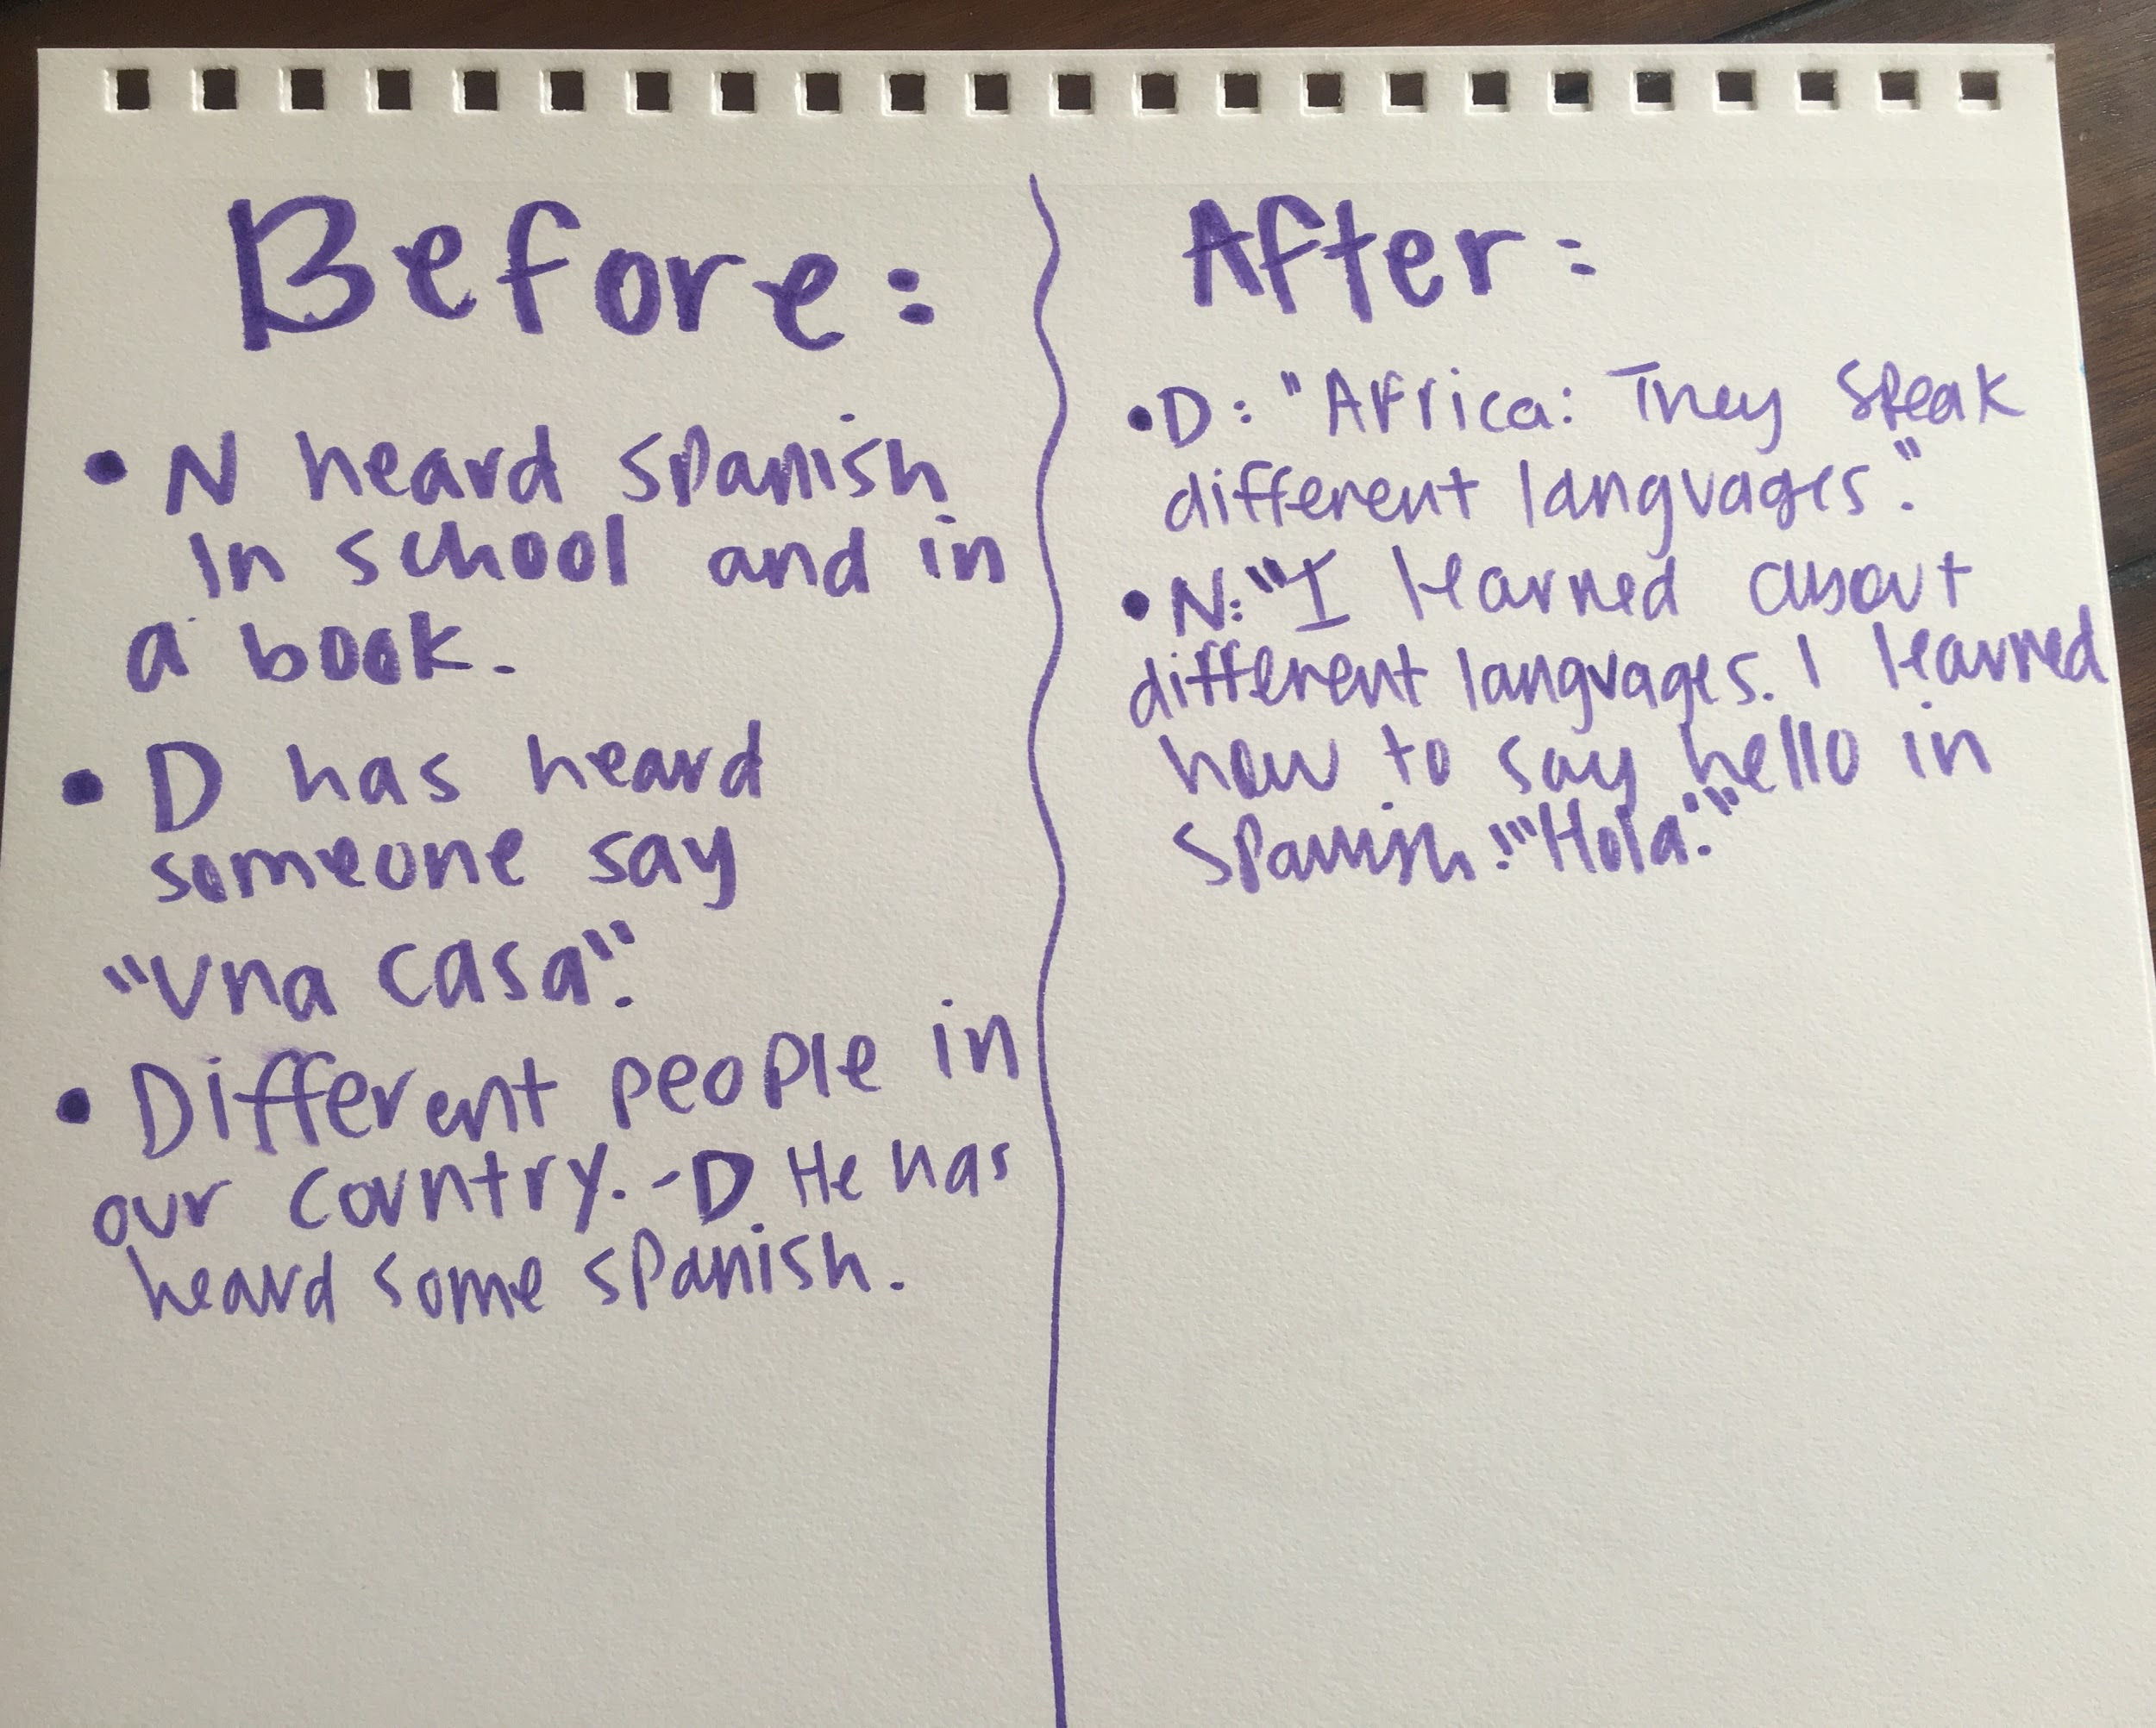  “What do you think multilingualism is?” We asked the two students to draw what they thought it was on their papers.  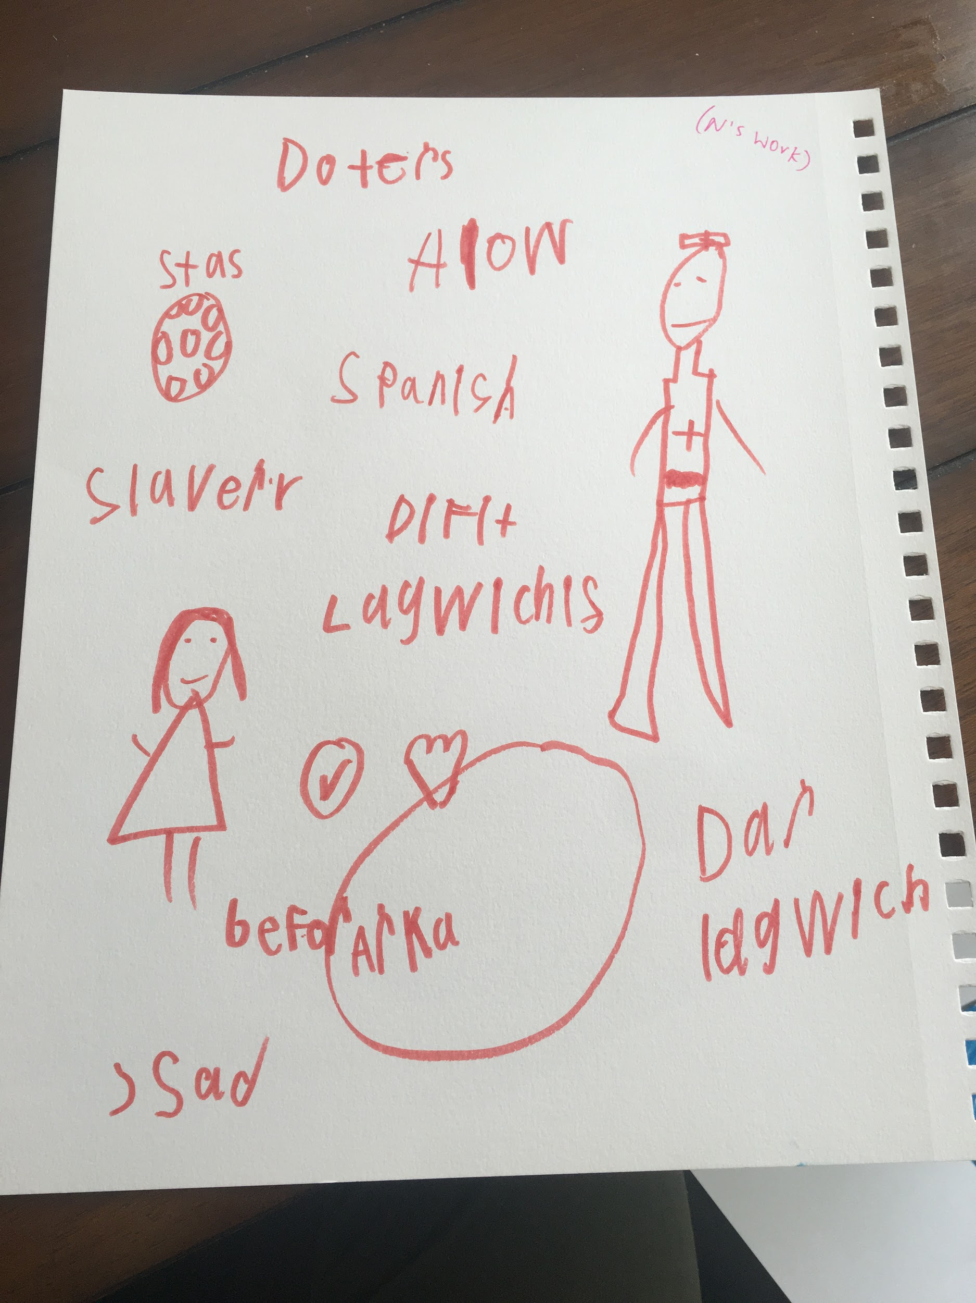  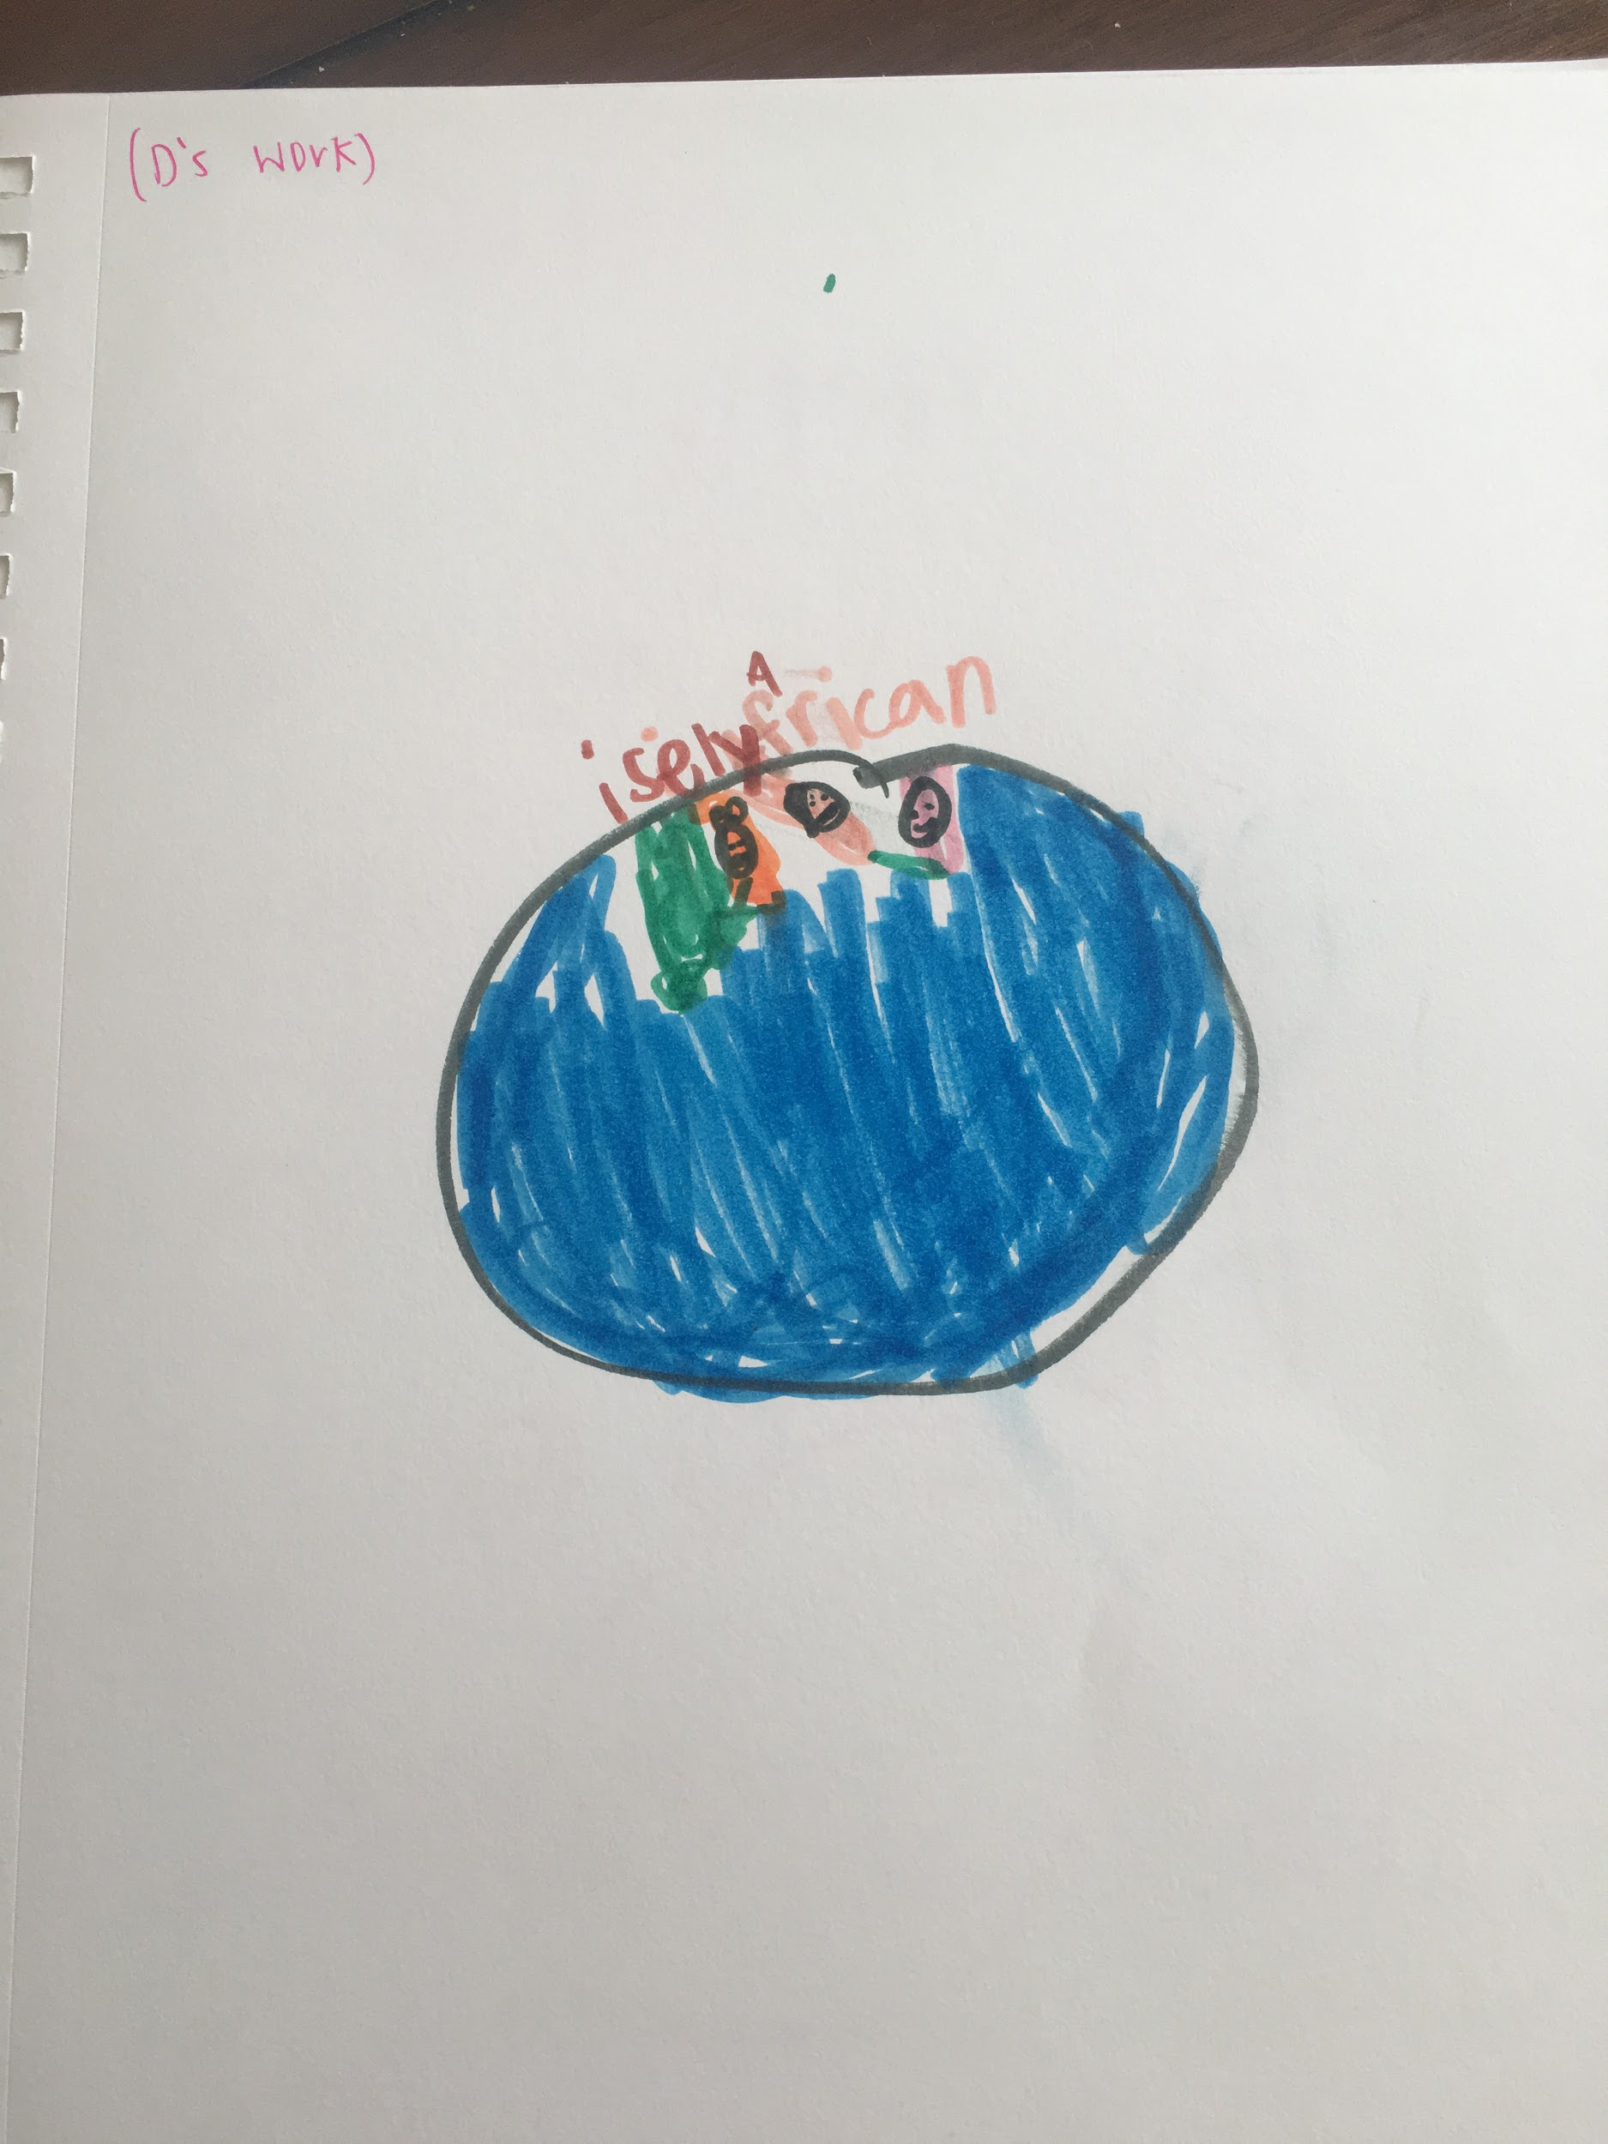  Images of the children creating the artwork from above:  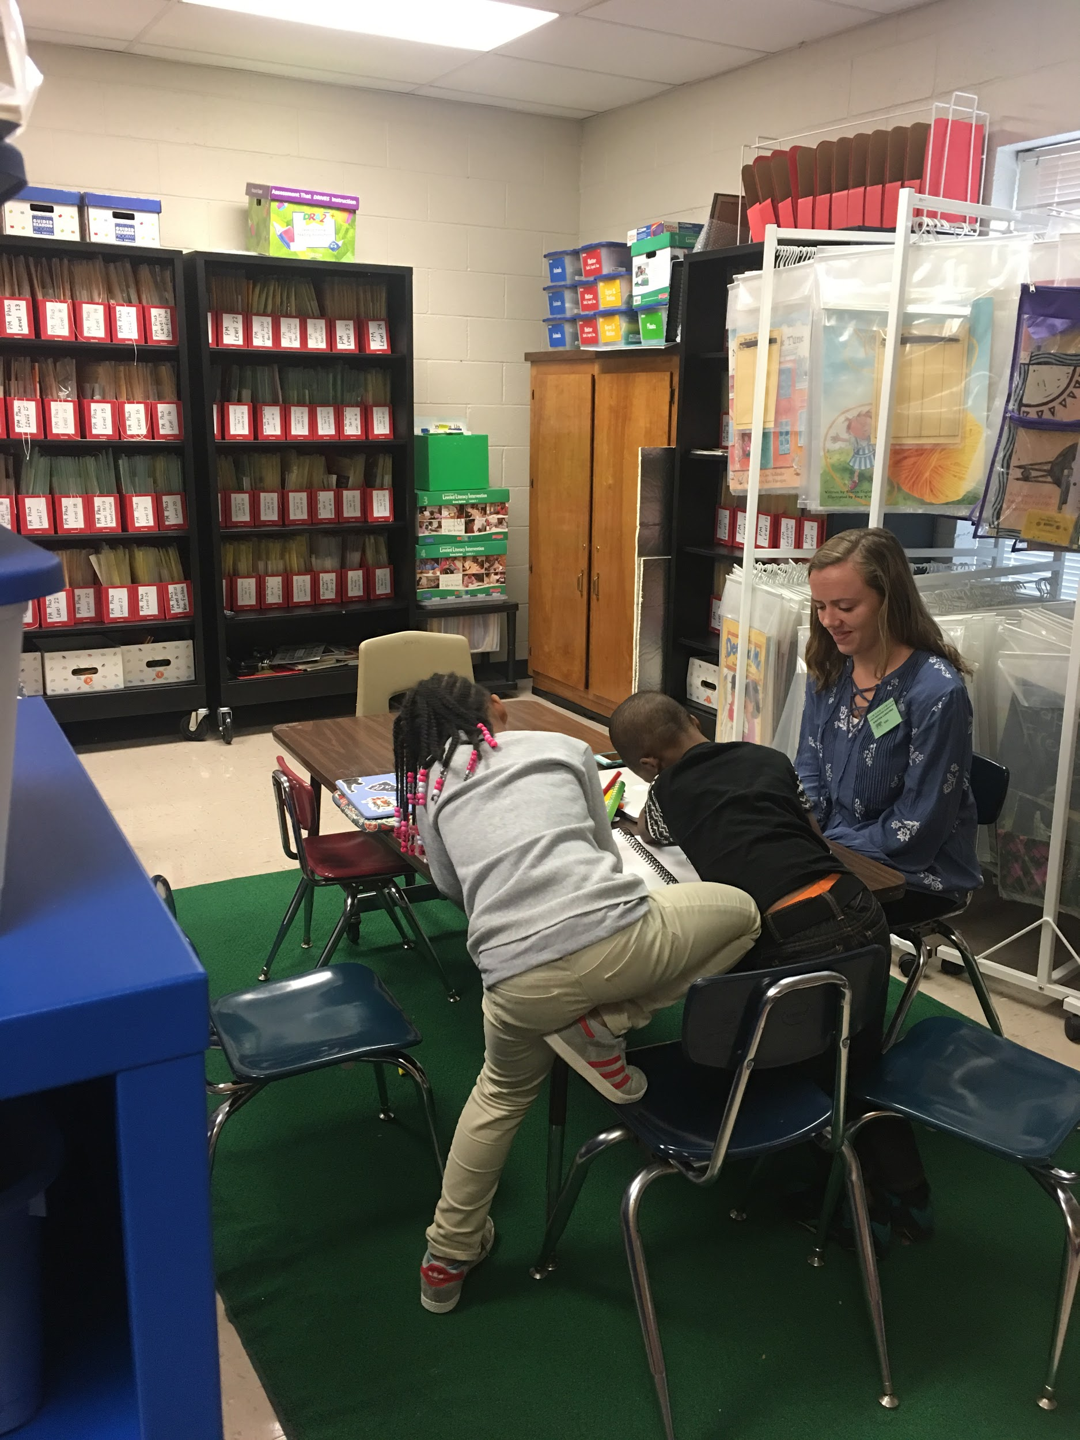  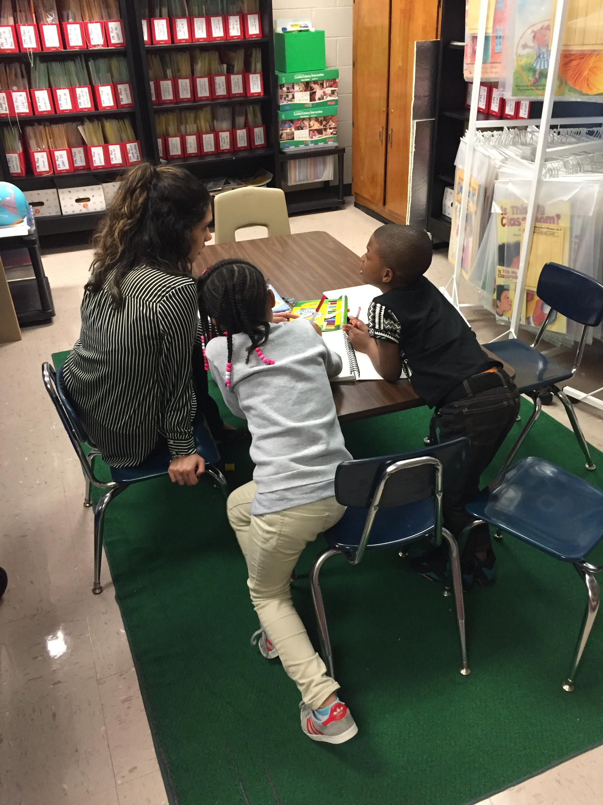 | During the day two of the lesson, I believe the students understood the lesson as a whole. I think they understood that there are such things as other languages and other cultures of people. I think they were able to understand AAL and Spanish. It was a bit difficult for them to understand the rules. I could tell by their facial expressions, but they were trying their best!!  One of the students caught onto AAL very quickly. He seemed to be more comfortable code switching Standard English to AAL than code switching Standard English to Spanish. Both students, however were very interested in learning about Spanish. | One student was absent for the third day. The student who was present enjoyed playing jeopardy with the teachers. While some of the questions were challenging, the student was able to answer most of the question by himself or with help. He really enjoyed the code switching and spanish questions. He is a student who does not enjoy just sitting and reading as much, so the game was a perfect way to get him engaged in the content we had been focusing on. For one of the questions, it asked “How do you say Hello in Spanish?” Child D exclaimed with some thought…. “Hola?”. This demonstrates the child’s understanding of another language and how to code switch or translate from english to spanish.
Reflection on Self: (what you did well, what you would do differently the next time). | I think that we did a good job by deciding to only talk about multilingualism and bilingualism today. We did not think it was a good idea to introduce AAL and Spanish along with the one big new concept of ‘Multilingualism.” I believe that it went more smoothly than we thought.  Something we will do next time to improve is to try to maybe find a book that does well talking about multilingualism. This would be a better introduction to the subject or a way to wrap it up before the children draw. | During the second lesson, I think that we did a fairly good job. It was difficult explaining the specific grammar rules to the children. I think it was hard for them to understand since they are still in the process of learning to read Standard English. They did really enjoy hearing about the history of the languages, such as learning about how the African Americans were also scientists, doctors, queens and kings before being captured and brought to America. Next time, I think it would be best to try and use less text on the slides. Just verbally give them examples and have them practice with us. I know for sure they did enjoy reading the stories. They liked hearing us read them in the different languages. | This day went well. We created a good Jeopardy game that was engaging and kept Child D’s attention. We think that we could have made the questions MUCH easier. And if we could go back and do this again we would make the questions easier for the students so that they could complete it on their own. We also could have used visuals to go with the questions to aid the students. Overall, the students would benefit if this lesson plan as a whole was taught over a longer span of time. The content of the lesson was new, so students may have needed more time to soak in the information and practice using it.

